1. Introduction
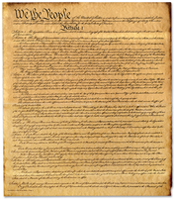
When the delegates left Independence Hall in September 1787, they each carried a copy of the Constitution. Their task now was to convince their states to approve the document they had worked so hard to write.
Writing the Constitution involved many compromises. Most of all, the framers wanted to create a central government that would be strong and lasting but not so strong that it endangered citizens’ freedoms. In this chapter, you will see how the Constitution met these goals.
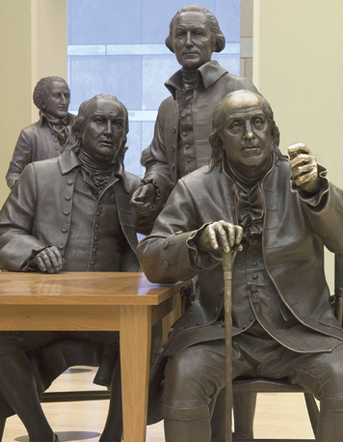
The delegates wanted ordinary citizens to understand and support the Constitution. For this reason, they organized its contents very clearly. After a short introduction, they divided the Constitution into parts called articles. Then they split each article into numbered sections that present topics in a careful order.
This structure can help you find information in the Constitution. For instance, the first section in the article on the president describes how the president is chosen. The second section lists the president’s powers. The third section lists presidential duties, and the fourth explains how the president can be removed from office.
One of the marvels of the Constitution is the way it combines flexibility with a strong framework for the government. In general, the delegates allowed Congress, the president, and the courts to add details to the basic framework. They also included procedures for changing the Constitution.
This combination of strength and flexibility makes the Constitution an enduring document. The Constitution keeps its basic nature, yet the framers created it so it could also change with the times. In this chapter, you will learn more about the enduring quality of this ingenious document.

2. The Preamble Tells the Goals of Government
The delegates who crafted the Constitution chose each word carefully. Some of their best-known words are in the introduction, which is called the Preamble. The Preamble explains the reasons for the new government.
The Constitution begins with the memorable phrase “We the People.” With these words, the delegates announced that the Constitution based its authority on the people themselves. The power to form the government did not come from the states or the existing government. It did not come from a sovereign (ruler) appointed by God. Instead, the power came from ordinary Americans. This concept is known as popular sovereignty.
The Preamble then lists the goals of the new government. First, the delegates wanted to “form a more perfect Union.” What did the delegates mean by this? They wanted the states to cooperate with each other. They also wanted to create a strong relationship between the states and the national government.
The Constitution also aims to “establish Justice.” Americans wanted to be ruled by laws, not by the might of soldiers or the decisions of kings. The same laws would apply to all people.
The delegates hoped that the new government would “insure domestic Tranquility.” By domestic, they meant within the country. By tranquility, they meant peace and order. It was the government’s job to keep peace and maintain order within the country.
The new government would “provide for the common defence.” In other words, the national government would be responsible for protecting the nation against foreign enemies. This would allow for stronger protection than would be possible if each state had its own army and navy.
The delegates wanted the new government to “promote the general Welfare.” This meant that the government could support an economy and a society in which people could prosper.
Finally, the delegates hoped to “secure the Blessings of Liberty to ourselves and our Posterity.” By “posterity,” the delegates meant the generations that would come after them. They wanted the government to protect the freedoms gained in the American Revolution and preserve them for Americans to enjoy in the future.
The delegates knew that these goals required a national government. However, based on their experience with a king, many people were suspicious of a strong central government. For this reason, the delegates tried to create a balanced framework that people could trust.
3. The Legislative Branch Makes Laws
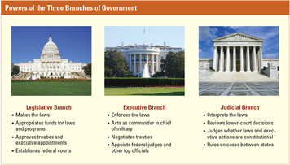
For the framers of the Constitution, the first step in building a trusted government was to create a fair way to make laws. Article I of the Constitution gives the power to make laws to the legislative branch of government.
The Structure of Congress The Constitution creates a bicameral, or two-part, national legislature called Congress. The two parts, or houses, of Congress are the House of Representatives and the Senate.
Members of the Senate serve six-year terms so that they can enjoy some independence from the day-to-day opinions of voters. In contrast, members of the House serve two-year terms. As a result, they have to face the voters much more often. In this way, the framers tried to balance the independence and thoughtfulness of the Senate with the House’s responsiveness to the changing wishes of the voters.
The framers also designed Congress to balance the rights of large and small states. Thus, while every state gets two senators, representation in the House is based on population. States with more people have more representatives in the House. To determine the number of representatives for each state, the Constitution calls for a census (a count of the population) to be conducted every ten years. In time, the number of representatives in the House was set at 435, divided among the states based on their population.
The framers considered the Senate to be the “upper house” of the legislature. Its members are supposed to be wiser and more experienced than members of the “lower house.” Senators must be at least 30 years old, while House members must be 25. Senators must have been citizens for nine years, House members for just seven years.
Originally, the Constitution allowed state legislatures to choose the two senators to represent their state. Today, however, senators are elected by popular vote (direct vote by the people).
How Congress Makes Laws The primary job of Congress is to make laws. Any member of the House or Senate can submit a proposal for a new law, called a bill. However, only the House can propose new taxes. If a majority in one house votes in favor of the bill, it is sent to the other house for debate. If both houses approve the bill, it goes to the president. The bill becomes a law if the president signs it.
The president can veto any proposed law. Congress can override the president’s veto, which means passing the bill over the president’s objections. But to do so requires a two-thirds majority in both houses.
The Powers of Congress Article I spells out other powers of Congress. For example, only Congress can decide how to spend the money raised through taxes. Other congressional powers include the power to raise an army and navy, to declare war, to pay government debts, and to grant citizenship.
In addition, Congress may “make all Laws which shall be necessary and proper” to carry out its other powers. This power, known as the elastic clause, gives Congress the flexibility needed to do its job. Over the years, the elastic clause has been stretched to allow Congress to do many things that were never listed among its powers in the Constitution.

4. The Executive Branch Carries Out the Laws
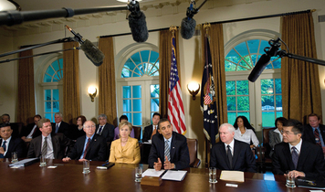
A government needs people to carry out, or execute, the laws passed by the legislature. For instance, when Congress approves a tax, someone must collect the money. When Congress appropriates, or sets aside, money for low-cost housing, someone must build and manage the housing.
Article II of the Constitution describes the branch of government that fills this role, the executive branch. The head of the executive branch is the president. The president is often called the chief executive.
Electing the President Delegates at the Constitutional Congress were not prepared to let the people elect the president directly. Instead, they decided that the president would be selected by a group of electors. Each state would have the same number of electors as it had representatives and senators in Congress. To win the presidency, a candidate needs a majority of the electoral vote.
The president serves a four-year term. Under the Twenty-second Amendment, a president may be reelected only once. A new president makes a solemn promise called the oath of office. The Constitution gives the exact words of the oath. The oath calls for the president to “defend the Constitution.” These words reinforce the importance of the Constitution as the basic law of the land.
A president must be a natural-born American citizen and at least 35 years old. The Constitution always refers to the president as “he.” The delegates to the Constitutional Convention probably assumed that only men would ever vote or hold office. But nothing in the Constitution prevents a woman from being elected president.
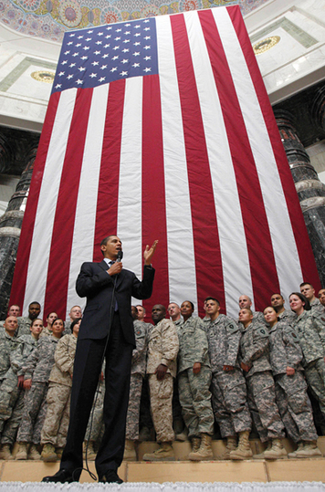
The Powers of the President In addition to carrying out laws passed by Congress, the president is commander in chief of the nation’s military forces. He or she can, with the consent of the Senate, make treaties, or formal agreements, with other nations. The president nominates, or recommends, ambassadors (official representatives to other countries) and Supreme Court justices (judges). Finally, the president can grant pardons to people convicted of violating federal, or national, laws.
The framers expected that the executive branch would need organizations, called departments, to carry out its duties. For example, the State Department handles relations with other nations. The Justice Department is involved in law enforcement as well as court actions. The heads of executive departments are members of the president’s cabinet, a formal group of advisers.
Today, the executive branch has over a dozen executive departments. Each executive department contains smaller, specialized agencies. For instance, the Department of Health and Human Services contains the Food and Drug Administration. This agency works to ensure that foods and medicines meet safety standards that have been set by Congress.
Removing the President The Constitution gives Congress the power to remove a president or other officials from office if they commit certain crimes related to their duties. The House of Representatives can vote to impeach the president. To impeach means to formally accuse the president of the crimes specified in the Constitution. These include “Bribery, or other high Crimes and Misdemeanors.” If the House votes to impeach, the Senate puts the president on trial, with the senators serving as the jury. If found guilty, the president is removed from office.

5. The Judicial Branch Interprets the Law
The framers intended for the Constitution to be the “supreme Law of the Land.” That means no other laws or actions by the government or by any state can conflict with the Constitution. Protecting the Constitution is one of the principal responsibilities of the third branch of government, the judicial branch. The judicial branch consists of the system of federal courts and judges.
Article III of the Constitution gives the basic framework of the judicial branch. It establishes the country’s highest court, the Supreme Court. It also gives Congress the power to create inferior (lower) courts to meet the nation’s needs.
Federal courts also have the power to resolve disputes that involve national laws, the federal government, or the states. People accused of breaking national laws can be tried in federal courts.
Federal Court System Congress has authorized two main sets of inferior federal courts. These lower courts are called district courts and appellate courts.
Most cases involving federal laws are first heard in district court. The United States is divided into large geographic districts. Each district covers several states. Citizens can appeal decisions given in district court, which means asking a higher court to review the case. Courts that review cases are called courts of appeal or appellate courts. An appellate court only considers whether the original trial was fair and legal. A decision by an appellate court can be appealed to the Supreme Court.
The Powers of the Supreme Court The Supreme Court is the last stop in the judicial system. Its decisions are final, and they are binding on all lower courts. The Constitution does not specify the size of the Supreme Court. Congress has set the size at nine members, who are called justices. The Constitution says that all federal judges, including Supreme Court justices, serve for “good Behaviour.” Once they are appointed, justices usually serve on the Court for life.
A dispute goes directly to the Supreme Court only if it involves a state or an ambassador from another country. Any other case comes to the Supreme Court after a trial and an appeal in lower courts. Participants in either national or state courts may eventually appeal cases to the Supreme Court.
Every year, lawyers ask the Supreme Court to review thousands of cases, but the Court agrees to consider only about a hundred. The Supreme Court usually reviews a case only if the justices think the decision made by a lower court might conflict with the Constitution or a federal law. After hearing statements from both sides, the justices debate among themselves and vote. Supreme Court decisions are announced and explained in writing. These decisions then guide later decisions in lower courts.
Early in its history, the Supreme Court defined the power of judicial review. This is the power to decide whether laws and acts made by the legislative and executive branches conflict with the Constitution. Courts all over the country rely on the Supreme Court for guidance about what is constitutional. Judicial review gives the Supreme Court great power in its role of protecting the “supreme Law of the Land.”

6. Checks and Balances Between the Branches
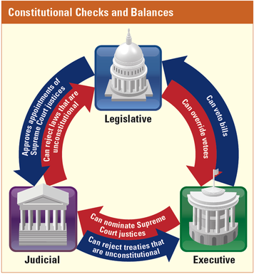
The framers of the Constitution were very concerned about achieving a balance between a strong national government and protection for individual freedoms. They hoped that dividing the federal government into three branches was one way to limit the government’s power. But what would keep one branch from dominating the others? As one delegate to the Constitutional Convention pointed out, “From the nature of man, we may be sure that those who have power in their hands . . . will always, when they can . . . increase it.”
Because of this concern, the framers developed a system that would enable each branch of the government to limit the power of the other two branches. This system is called checks and balances.
Checking the Power of Other Branches Checks allow one branch to block the actions of another branch. For instance, Congress has the power to pass laws. But the president can check this power by vetoing a bill before it becomes law. In turn, Congress can check the president’s power by overriding the veto by a two-thirds majority vote in each house.
Similarly, the judicial branch can check the actions of the other two branches. Through its power of judicial review, the Supreme Court can declare that a law, a treaty, or an executive action is unconstitutional.
Balancing the Power of Other Branches Balances allow each branch of the government to have some role in the actions and power of the other branches. For instance, judges, ambassadors, and cabinet members are appointed only if the president nominates them and the Senate approves the nomination. Similarly, the president has the power to sign treaties, but they take effect only if the Senate approves them.
The powers of the judicial branch are also balanced against the powers of the other two branches. Even though the Supreme Court can declare laws unconstitutional, it is the president who chooses federal judges—and the Senate must approve these appointments. In addition, Congress can impeach federal judges. In these ways, the legislative and executive branches have some role in the actions of the judicial branch.
These checks and balances keep any one branch of the federal government from being too strong. This balance of powers is one of the most important features of the U.S. system of government.

7. The Amendment Process
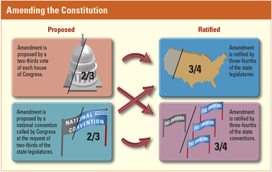
The framers knew that the Constitution would need to be changed over time. As Thomas Jefferson said, “the earth belongs to the living and not to the dead.” At the same time, they wanted the Constitution to provide a lasting and stable framework for the government. To maintain that stability, the framers made changing the Constitution possible but difficult.
Changing the Constitution Article V describes how changes, called amendments, can be made to the Constitution. An amendment may be proposed in one of two ways. Congress may propose an amendment by a vote of at least two-thirds of each house of Congress. Or, a national convention called by Congress at the request of at least two thirds of the state legislatures may propose an amendment. Thus, either Congress or the states can start the process of amending the Constitution.
Proposing an amendment is only the first step. Before an amendment can become part of the Constitution, it must be ratified. The Constitution gives two ways of ratifying an amendment. An amendment may be approved by the legislatures in at least three-fourths of the states, or it may be ratified by special conventions in at least three-fourths of the states. Once an amendment is approved, it becomes part of the Constitution.
Amendments So Far Over the years, people have suggested more than 10,000 amendments to the Constitution. Only 27 have been approved. The first 10 amendments were added almost immediately after the Constitution was ratified. These amendments were demanded by many Americans in exchange for their support of the Constitution. Called the Bill of Rights, these 10 amendments primarily guarantee specific rights to citizens.
The other 17 amendments became part of the Constitution one at a time. Some of them changed the way certain public officials are elected. Others guaranteed the rights of certain groups of Americans. The Thirteenth Amendment made slavery illegal. The Nineteenth Amendment guaranteed women the right to vote. The Twenty-sixth Amendment gave the right to vote to all citizens over the age of 18.

8. The Federal System Connects the Nation and the States

The framers of the Constitution wanted a strong national government, but they also wanted the states to keep significant powers. They accomplished both goals by creating a federal system of government in which power is shared between the national and state governments.
Powers Belonging to the National Government The Constitution gives some powers only to the national government. In general, these are powers best exercised by one central authority, such as declaring war and making treaties. The Constitution also says that only the national government can print and coin money. The framers had learned from experience that separate state currencies made no sense.
Similarly, Article I gives Congress the power “to regulate Commerce with foreign Nations, and among the several States, and with the Indian Tribes.” Known as the commerce clause, this provision gives the national government the power to regulate interstate commerce. For example, a state cannot try to protect its own businesses and industries by taxing goods imported from other states. Under the Articles of Confederation, many states had done just that. As a result, interstate trade threatened to grind to a halt. In effect, the commerce clause made the entire United States a common market, or free-trade zone.
There were several advantages to giving states a common market. First, goods and resources could flow more easily across the country. This is important because different regions do different things well. New Englanders might be very good at making cloth, but their region is not good for growing cotton. Southerners might have lots of cotton but few factories for turning it into cloth. Making interstate trade easier for cloth makers and cotton growers helps both businesses thrive.
Second, the common market made it easier to create large businesses that crossed state lines. This was very important to companies like those that built the nation’s railroads in the 19th century.
Third, the common market helped to create a single national economy. Under the Articles of Confederation, it was almost as if the country had 13 small economies. These could never have grown as diverse or powerful as the U.S. economy did.
Notice that the commerce clause also gives the national government the right to regulate trade with Indian tribes. In effect, the Constitution treats native tribes as foreign governments. Relations with these “nations within a nation” are the responsibility of Congress, not the states.
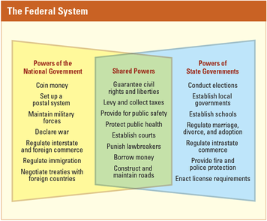
Powers Belonging to the States The Constitution does not spell out specific powers of the states. Instead, it says that the states retain, or keep, any powers that are not given to the national government. For instance, the Constitution says nothing about schools, marriage, establishing local governments, owning property, licensing doctors and lawyers, or most crimes. The states make the laws in these areas of life.
The Constitution does, however, outline the responsibilities of states to each other. Article IV says that each state must give “full Faith and Credit” to the laws and court decisions of other states. This means accepting other states’ laws and court decisions as legal. For example, a driver’s license issued in one state is legal in every state. Similarly, states must obey legal contracts that people have made in other states. Like the commerce clause, the full faith and credit provision brings stability to business dealings. States are also required to help each other track down fleeing criminals. Criminals cannot escape justice by fleeing to another state.
Finally, the Constitution does not allow one state to discriminate unreasonably against a citizen of another state. A state may not, for example, refuse to let a child who was born in another state attend its public schools.
Shared Powers Federal and state governments also share some powers. For example, both levels of government can collect taxes, build roads, borrow money, and regulate education.
If you think federalism, or the sharing of power, sounds complicated, you are right. Consider presidential elections. Congress sets the date for national elections, while the states register voters and run the elections. States count the ballots, while the national government organizes the Electoral College vote, which determines who will be president.
Federalism is also complicated because the Constitution provides only a general framework for the sharing of powers. There was no way for the framers to spell out rules for every possible situation. The federal system continues to evolve through new laws, court decisions, and constitutional amendments.
The Law of the Land Americans may disagree about how to interpret the Constitution, but they may not ignore it. Article VI states that the Constitution and the laws flowing from it are the “supreme Law of the Land.” This means that a state’s constitution, laws, and judicial decisions must agree with the Constitution. They also must not conflict with any other federal laws or treaties. In addition, everyone who holds a state or federal office must promise to support the Constitution.

9. Popular Participation in Government

The framers of the Constitution designed a government based on the will of the people. They expected people to take part in their own government and to hold leaders responsible for their actions.
For government to reflect the popular will, it makes sense for its decisions to be based on what most people want. The Constitution therefore establishes the principle of majority rule. Laws are passed in Congress by majority vote. Elections are decided by a majority of voters.
It is through elections that most people have a say in what the government does. Leaders must listen to the voters, or they will not be elected (or reelected). Elections serve the vital function of expressing the will of the people.
But who exactly are “the people”? The framers did not specify who would have the right to vote. Over the years, states established various requirements for voting. It took many years of struggle to establish the principle that all citizens should have the right to vote. Women, for example, were not guaranteed this right until the Nineteenth Amendment was ratified in 1920.
Popular participation in government has evolved in other ways that are not part of the Constitution. For example, the Constitution makes no mention of political parties. Today, parties select most candidates for political office. Becoming active in party affairs is another way that voters can help choose their leaders and influence the positions they take on issues.
People also take part in government indirectly through interest groups. There are interest groups for almost any issue that people might care about. Some interest groups represent businesses, industries, and workers. Some represent groups of people, such as churchgoers, women, or minorities. Some are organized around issues, such as the environment or health care.
Interest groups influence government in several ways. They rally public opinion, work to elect candidates who promise to listen to them, and try to persuade lawmakers and government officials to take actions they favor.
If the framers were alive today, they might be surprised to see the changes in the system they created. Yet the remarkable thing is how successful they were in building the basic framework of American democracy. As one historian has said, the Constitution “would become the rule of life for a country larger than any of the founders imagined, and would last longer than most of them dared hope.”

Summary
In this chapter, you learned how the Constitution met the delegates’ goal of creating “a more perfect Union.”
The Preamble As the first words of the Preamble tell us, the Constitution’s authority comes directly from the people, not the states. This concept is known as popular sovereignty. The Preamble goes on to list the goals of the new government.
The Legislative Branch Article I of the Constitution creates a bicameral Congress with a House of Representatives and a Senate. Every state is represented by two senators. Representation in the House is based on a state’s population. Congress’s primary job is to make laws.
The Executive Branch Article II creates the executive branch. The head of the executive branch is the president. The president serves a four-year term and may be reelected once. The president carries out laws passed by Congress. Other powers of the president include making treaties and appointing Supreme Court justices.
The Judicial Branch Article III establishes the Supreme Court and gives Congress the power to create lower courts. Supreme Court decisions are binding on all lower courts. The power of judicial review allows the Supreme Court to decide whether laws and actions by the legislative and executive branches are unconstitutional.
Checks and Balances The framers developed a system of checks and balances that enables each branch of government to limit, or check, the power of the other two branches. The Constitution provides checks and balances in the powers of each branch.
The Amendment Process Article V outlines the process by which amendments can be made to the Constitution. Twenty-seven amendments have been added. The first ten amendments form the Bill of Rights.
The Federal System The Constitution creates a federal system of government in which power is shared between the national government and the states.
Popular Participation in Government Elections serve the vital function of expressing the will of the people. People also participate in government by joining political parties and taking part in interest groups.

Reading Further - Who Are “We the People”?
The Constitution begins with the words “We the People.” But just who were these people who wanted to “secure the Blessings of Liberty”? In 1787, “We the People” excluded more than half the population, including African Americans and women. What were the framers thinking?
Mum Bett had had enough. Born into slavery, she had served in the home of John Ashley of Sheffield, Massachusetts, for more than 30 years. When Mrs. Ashley hit her with a hot kitchen shovel one day in 1781, Mum Bett fled and refused to return.
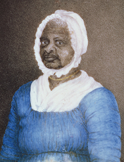
Instead, Mum Bett asked a lawyer, Theodore Sedgwick, to represent her in court. Mum Bett wanted to be free, and she believed the courts would recognize that she had the right to freedom. Sedgwick took her case.
Mum Bett, who later changed her name to Elizabeth Freeman, knew about the Massachusetts state constitution. It had been ratified in 1780. Mum Bett had heard that it said that “all people were born free and equal.” She believed that “all people” included her and that she had a legal right to her freedom. The court agreed, and Mum Bett became a free woman. John Ashley, her former master, had to pay her 30 shillings in damages.
Though the court ruled in favor of Mum Bett, the problem of just who would be included in “We the People” did not go away. It surfaced again just a few years later. In 1787, the leaders of the United States met in Philadelphia. They wrote a constitution for their new country. But they did not pay attention to the Massachusetts court’s decision that Mum Bett was free. Initially, the U.S. Constitution excluded women and African Americans from enjoying the full benefits of liberty.
The colonies had fought the revolution to gain their freedom. They created a democracy, but many people were disallowed from participating in it. Neither African Americans nor women could vote or hold office. These groups had to fight for many years to gain the right to take part in these democratic processes. But the question arises: why were they excluded in the first place?
The Responsibilities of Freedom
The 55 white men who wrote the U.S. Constitution were a privileged group. More than half of them had been to college, 34 had studied law, almost half had been in Congress, and at least 20 owned slaves. The delegates were hardly typical of the larger American population at the time. But, in many ways, they reflected the general beliefs of 18th-century American society.
The framers of the Constitution believed that only certain people could handle the responsibilities of freedom. The way they viewed it, only people who controlled their own lives should have a say in the government. Dependent people—those who didn’t own property or who worked for someone else—could not exercise their own free will, the framers reasoned. If they voted, they would cast their ballots as they were told to. The framers believed that the votes of such people would damage the entire country.
To the framers, as to many Americans in those days, only a property owner could be an independent thinker. That excluded more than half of the population. “We the People” were white, male, and propertied.
Some of the excluded could eventually join fully in civic life. For example, indentured servants completed their service after a number of years. They might eventually own property. Some women might inherit property from their husbands. But few women were likely ever to enjoy all the rights the Constitution promised.
And many people were completely locked out of economic opportunity. Slaves could never own property. They could never be independent and free. The American system made it impossible for them to share as citizens in the new United States.
Neither women nor African Americans simply accepted their exclusion, however. For many years, until they were successful, both women and African Americans would argue that they should be able to participate fully in American democracy.
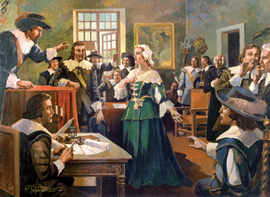
The Rights of Women
Perhaps the most famous woman to speak out for women’s rights at the time was Abigail Adams. Her husband, John Adams, would become the second president of the United States. In the spring of 1776, when John was a delegate to the Continental Congress, Abigail wrote to him, saying,
In the new code of laws which I suppose it will be necessary for
you to make, I desire you would remember the ladies . . . Do not
put such unlimited power into the hands of husbands. Remember,
all men would be tyrants if they could.
Abigail Adams knew that in the 18th century, women had legal status only through their husbands. A married woman was called a feme covert, a legal term that comes from the French words for “covered woman.” Women were “covered”—invisible as far as the law was concerned— by their husbands. Abigail warned her husband that women would not follow any laws that did not guarantee their rights. They would not be “bound by any laws in which we have no voice or representation.”
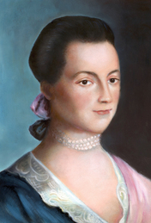
John Adams, however, feared that expanding freedom would lead to chaos. He told Abigail that women had more power over their husbands than they realized. That being true, he believed that men would be better off excluding women from the new country’s laws. “Depend upon it,” he wrote, “we know better than to repeal our masculine systems.”
Nonetheless, some women did vote during the republic’s early years. A New Jersey law, passed in 1790, identified voters as “he or she.” Historians disagree about why. Some point out that New Jersey was home to many Quakers, who believed in equality. Others call attention to the fact that only some counties granted women the vote and say it was more about political power. These counties, they say, hoped women’s votes would affect election outcomes in their favor. Whatever the reasons, women voted in New Jersey until the law was repealed in 1807. It would take more than 100 years—and a hard fight—to pass an amendment to the Constitution that granted women the right to vote.
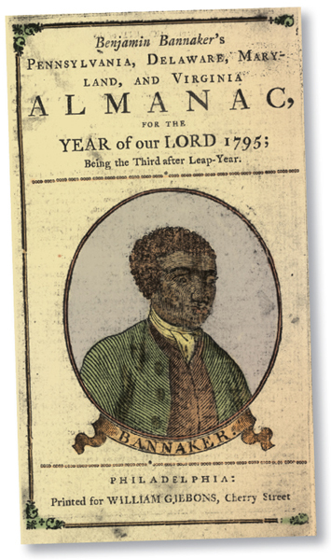
The Rights of African Americans
When the war ended, many African Americans left the United States. They feared that the new democracy would not include them. Some went to England. Others went to Canada or the West Indies. Most of those who left were fugitive slaves. By some accounts, 30,000 African Americans left Virginia. Another 25,000 left South Carolina.
The majority of the African Americans who stayed were slaves. But some were not. The 1790 census reported that there were about 59,000 free blacks living in the United States. Among them was Benjamin Banneker. Banneker was a Maryland tobacco farmer, a scientist, and a surveyor. He wrote a well-known almanac. He also wrote a letter to Thomas Jefferson. In it, he explained why African Americans should have the same rights as whites.
Banneker wrote the letter in 1791, the year in which he surveyed the land for the new national capital. At the time, Jefferson was secretary of state. Banneker explained that both blacks and whites were created by God. “However variable we may be in society or religion,” he wrote, “however diversified in situation or color, we are all of the same family.” He went on to quote the Declaration of Independence— to the man who wrote it.
“We hold these truths to be self-evident, that all men are created
equal; that they are endowed by their Creator with certain unalienable
rights, and that among these are life, liberty, and the pursuit
of happiness.”
Banneker explained that African Americans deserved those rights, just as whites did. He even went so far as to accuse Jefferson of using “fraud and violence” to keep blacks enslaved.
Although a slaveholder himself, Jefferson wrote back that “No body wishes more than I do, to see such proofs as you exhibit, that nature has given to our black brethren talents equal to those of the other colors of men.” But slavery continued in the South until the Civil War.
The freedoms guaranteed by the Constitution would not be extended African Americans for many years. African American men gained the right to vote in 1870. It would take another 50 years before all women, including African Americans, were granted voting rights. And not until the 1960s were laws passed giving all African Americans the legal protection to exercise their right to vote.
The words “We the People” still begin our Constitution. More than 200 years later, their meaning has changed in ways that Mum Bett, Abigail Adams, and Benjamin Banneker would approve.

Enrichment Essay - The Florida Constitution
The Florida constitution sets up the structure of our state’s government. The constitution also explains the function and purposes of Florida’s state government. Florida’s constitution is the basic law of the state.
The Florida constitution divides the state government into three parts, or branches. These are the legislative, executive, and judicial branches.
The legislative branch the laws. Just as Congress makes laws for the United States, the Florida Legislature makes laws for Florida.
The Florida Legislature has two houses: the Senate and the House of Representatives. The Senate has 40 members. Its members are called senators. They serve four-year terms. The House of Representatives has 120 members. They serve two-year terms. Voters elect the members of both the State House and Senate.
The executive branch carries out the laws. In the federal government, the president is in charge of the executive branch. In Florida, the governor is in charge of the executive branch. Who is our governor? The Florida executive branch also has a cabinet. The cabinet has three members. Each member is the head of a state department. The cabinet members advise and make decisions with the governor.
The judicial branch makes sure that justice is done. It makes sure that people are treated fairly. The judicial branch includes all of the Florida state courts.
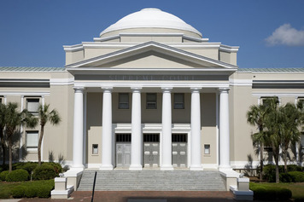
There are many kinds of courts in Florida. Each county has a county court. County courts can settle minor disputes, or disagreements, between citizens. They can also deal with minor criminal cases. If someone is caught speeding, they may have their case heard in a county court.
Florida has 20 circuit courts throughout the state. Circuit courts deal with serious cases, such as theft or murder. Circuit courts can also resolve major disputes between citizens.
Florida has five district courts throughout the state. A citizen who is unhappy with a decision from a circuit court may appeal to the district court. Judges in the district court will review the case. Then they will decide whether the original decision was just.
The highest court in Florida is the Supreme Court. It is located in Tallahassee. Some cases from lower courts are reviewed by the Supreme Court. The Supreme Court has the final word on Florida law.
Having three branches creates a separation of powers. The system of checks and balances makes sure no branch will have too much power. Each branch limits the power of the other two branches. For example, the Florida governor may veto, or stop, a law passed by the Legislature. However, two-thirds of the members of the Legislature can agree to overrule the veto and pass the law.

