DECLARATION OF INDEPENDENCE
1. Introduction
The battles of Lexington and Concord marked the start of the fighting that would lead to independence from Great Britain. The day after the clashes, horseback riders galloped through the colonies with news of the “barbarous murders” of innocent militiamen. Most Americans were deeply shocked. More urgently than ever, they debated what the colonies should do about the trouble with Great Britain.
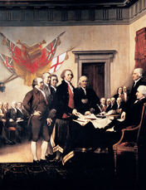
Click to read caption
The choices were clear enough. The colonies could declare their independence. Or they could continue with protests and petitions, or formal requests. This second choice would keep the colonies at peace, but at what cost to the colonists’ freedom?
No one was more outspoken in his support for independence than Patrick Henry of Virginia. After the passage of the Intolerable Acts, Henry delivered to the Virginia House of Burgesses one of the most famous speeches in American history.
“There is no longer any room for hope,” he began. “If we wish to be free . . . we must fight! Our chains are forged! Their clanking may be heard on the plains of Boston. The war is inevitable—and let it come!”
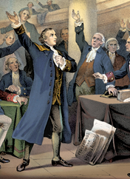
Click to read caption
Then Henry spoke to those who treasured peace above freedom:
Gentlemen may cry, Peace, peace—but there is no peace.
The war is actually begun. The next gale that sweeps from the north
will bring to our ears the clash of resounding arms! . . . What is it
that gentlemen wish? . . . Is life so dear, or peace so sweet, as to be
purchased at the price of chains and slavery? Forbid it, Almighty
God! I know not what course others may take; but as for me, give
me liberty, or give me death!
Despite the passionate words of Patriots like Henry, most colonists remained unsure about separating from Great Britain. As you will read, only after the fighting started did they decide to declare independence.

- Write any phrases or sentences that you know from the Declaration of Independence. In your own words, explain what you think each of these phrases or sentences mean.

2. The Colonists Organize an Army
On May 10, 1775, the Second Continental Congress met in Philadelphia. By then, New England militia had amassed around Boston. The first question facing Congress was who should command this “New England army.” The obvious answer was a New Englander.
George Washington and the Continental Army John Adams of Massachusetts had another idea. He proposed that Congress create a “Continental army” made up of troops from all the colonies. To lead this army, Adams nominated “a Gentleman whose Skill and Experience as an Officer, whose . . . great Talents and excellent universal Character, would [unite] the colonies better than any other person” alive. That man was George Washington of Virginia, who had distinguished himself in the French and Indian War.
The delegates agreed. They unanimously elected Washington to be commander in chief of the new Continental army.
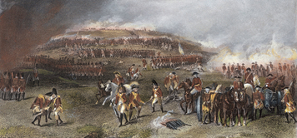
Click to read caption
The Battle of Bunker Hill Meanwhile, militiamen near Boston made plans to fortify two hills that overlooked the city: Bunker Hill and Breed’s Hill. On the night of June 16, 1775, Israel Putnam led a few hundred men up Breed’s Hill. In four hours of furious digging, they erected a crude fort on the top of the hill.
The fort worried British general William Howe, who had just arrived from England with fresh troops. Howe ordered an immediate attack. Under a hot June sun, some 2,000 British troops formed two long lines at the base of Breed’s Hill. At Howe’s order, the redcoats marched up the slope.
As the lines moved ever closer, Putnam ordered his men, “Don’t fire until you see the whites of their eyes.” Only when the British were almost on top of them did the militiamen pull their triggers. The red lines broke and fell back in confusion.
The British regrouped and attacked again. Once more the Americans stopped their advance. On their third attack, the redcoats finally took the hill—but only because the Americans had used up all their gunpowder and pulled back.
This clash, which became known as the Battle of Bunker Hill, was short but very bloody. More than 1,000 British troops and nearly half that many Americans were killed or wounded.
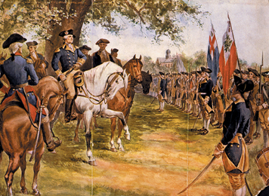
Click to read caption
General Washington Takes Command George Washington took command of his new army shortly after the Battle of Bunker Hill. He found “a mixed multitude of people . . . under very little discipline, order, or government.” Washington worked hard to impose order. One man wrote, “Everyone is made to know his place and keep in it . . . It is surprising how much work has been done.”
A month later, however, a dismayed Washington learned that the army had only 36 barrels of gunpowder—enough for each soldier to fire just nine shots. To deceive the British, Washington started a rumor in Boston that he had 1,800 barrels of gunpowder— more than he knew what to do with! Luckily, the British believed the rumor. Meanwhile, Washington sent desperate letters to the colonies begging for gunpowder.
Washington got his powder. But he still did not dare attack the British forces in Boston. To do that he needed artillery—heavy guns, such as cannons—to bombard their defenses. In desperation, Washington sent a Boston bookseller named Henry Knox to Fort Ticonderoga to round up some big guns.
Ticonderoga was an old British fort located at the southern end of Lake Champlain in New York. A few months earlier, militiamen led by Ethan Allen and Benedict Arnold had seized the fort. The Americans had little use for the run-down fort, but its guns would prove priceless.
As winter set in, Knox loaded 59 cannons onto huge sleds and dragged them 300 miles to Boston. Knox’s 42 sleds also carried 2,300 pounds of lead for making bullets. Boston was about to be under siege.
The British Abandon Boston On March 4, 1776, the British soldiers in Boston awoke to a frightening sight. The night before, the ridges of nearby Dorchester Heights had been bare. Now they bristled with cannons, all aimed at the city.
Rather than risk another battle, General Howe abandoned the city. Within days, more than a hundred ships left Boston Harbor for Canada. The ships carried 9,000 British troops as well as 1,100 Loyalists who preferred to leave their homes behind rather than live with rebels.
Some Americans hoped the war was over. Washington, however, knew it was only the beginning.
2. The Colonists Organize an Army Interactive Student Not
1. Who did John Adams propose should be commander-in-chief of the Continental army? What was the main reason he suggested this person?
2. Record four important details about the Battle of Bunker Hill (Breed’s Hill).
3. Describe the event that took place in each of these locations and explain explain the importance of the event.
• Ticonderoga (Winter 1775–1776)
• Boston (March 4, 1776)

3. On the Eve of Independence
Nearly a year passed between the skirmishes at Lexington and Concord and the British retreat from Boston. During that time, there was little talk of independence. Most colonists still considered themselves loyal British subjects. Their quarrel was not with Great Britain itself but with its policies toward the colonies.
The Olive Branch Petition Many Americans pinned their hopes for peace on King George. In July 1775, the Second Continental Congress sent a petition to George III asking him to end the quarrel. John Adams called the petition an “olive branch.” Olive tree branches are an ancient symbol of peace.
By the time the petition reached London, however, the king had declared the colonies to be in “open and avowed Rebellion.” He ordered his ministers “to bring the Traitors to Justice.”
Being called a traitor was enough to change the mind of one of Washington’s generals. The general confessed that he had long “looked with some degree of horror on the scheme of separation.” Now he agreed with Patrick Henry that colonists “must be Independent or Slaves.”
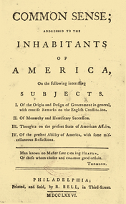
Click to read caption
Common Sense Many colonists, however, still looked with horror at the idea of independence. Then, early in 1776, a Patriot named Thomas Paine published a fiery pamphlet entitled Common Sense. Paine scoffed at the idea that Americans owed any loyalty to King George. “Of more worth is one honest man to society,” he wrote, “than all the crowned ruffians who ever lived.”
Paine also attacked the argument that the colonies’ ties to Great Britain had benefited Americans. Just the opposite was true, he said. American trade had suffered under British control. Americans had also been hurt by being dragged into Great Britain’s European wars.
Paine ended with a vision of an independent America as a homeland of liberty. “Ye that love mankind!” he urged. “Ye that dare oppose not only the tyranny, but the tyrant, stand forth! . . . The sun never shined on a cause of greater worth.”
Within a few months, more than 120,000 copies of Common Sense were printed in the colonies. Paine’s arguments helped persuade thousands of colonists that independence was not only sensible, but that it was the key to a brighter future.
Interactive Stud
1. Rewrite this sentence to make it correct: After the battles at Lexington and Concord and the British retreat from Boston, there were many more battles, and most colonists began to cry for independence.

- In the Venn diagram, record one similarity and three differences between the Olive Branch Petition and Common Sense.

4. Thomas Jefferson Drafts a Declaration
A few weeks after the British left Boston, the Second Continental Congress appointed a committee to write a declaration, or formal statement, of independence. The task of drafting the Declaration of Independence went to the committee’s youngest member, 33-year-old Thomas Jefferson of Virginia. A shy man, Jefferson said little in Congress, but he stated his ideas brilliantly in writing.
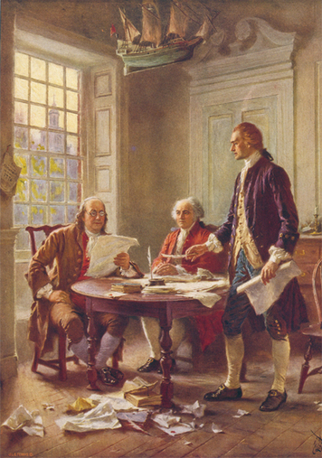
Click to read caption
Jefferson’s job was to explain to the world why the colonies were choosing to separate from Britain. “When in the Course of human events,” he began, if one group of people finds it necessary to break its ties with another, “a decent respect to the opinions of mankind” requires that they explain their actions.
Principles on Which to Base a New Government Jefferson’s explanation was simple but revolutionary. Loyalists had argued that colonists had a duty to obey the king, whose authority came from God. Jefferson reasoned quite differently. He based his arguments on the principle of natural rights. All people are born equal in God’s sight, he reasoned, and all are entitled to the same basic rights. In Jefferson’s eloquent words,
We hold these truths to be self-evident,
that all men are created
equal, that they are endowed
by their Creator with certain
unalienable Rights, that among
these are Life, Liberty, and the
pursuit of Happiness.
Governments are formed, Jefferson said, “to secure these rights.” Their power to rule comes from “the consent of the governed.” If a government fails to protect people’s fundamental rights, “it is the right of the people to alter or abolish it.” The people can then create a new government that will protect “their Safety and Happiness.”
The King’s Crimes King George, Jefferson continued, had shown no concern for the rights of colonists. Instead, the king’s policies had been aimed at establishing “an absolute Tyranny over these States” (the colonies).
As proof, Jefferson included a long list of the king’s abuses. In all these actions, Jefferson claimed, George III had shown he was “unfit to be the ruler of a free people.”
The time had come, Jefferson concluded, for the colonies’ ties to Great Britain to be broken. “These United Colonies are,” he declared, “and of Right ought to be Free and Independent States.”
1. Who drafted the Declaration of Independence? What was his main job in writing this document?
2. Write down three important ideas in the Declaration of Independence. Then explain why you think each idea is important.
5. The Final Break
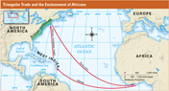
Click to read caption
On July 1, 1776, the Second Continental Congress met in Philadelphia’s State House to debate independence. By noon, the temperature outside had soared into the nineties, and a thunderstorm was gathering. Inside the State House, emotions were equally hot and stormy. By the end of the day, the issue was still undecided.
The next day was cooler and calmer. On July 2, all but one of the 13 colonies voted for independence. New York cast no vote.
No delegate was more excited about the colonies’ decision than John Adams. He wrote to his wife Abigail, “The second Day of July . . . will be celebrated, by succeeding Generations, with Pomp and Parade, with Shews (shows), Games, Sports, Guns, Bells, Bonfires and Illuminations, from one End of this Continent to the other from this Time forward forever more.”
Debate over Slavery Adams was wrong about the date that would be celebrated as America’s birthday, but only because Congress decided to revise Jefferson’s declaration. The delegates liked most of what they read, except for a passage on slavery. Jefferson had charged King George with violating the “sacred rights of life and liberty . . . of a distant people [by] carrying them into slavery.”
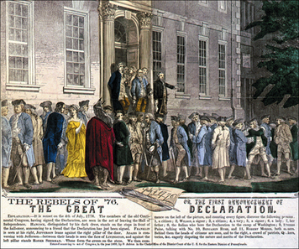
Click to read caption
Almost no one liked this passage. Southerners feared that it might lead to demands to free the slaves. Enslaved Africans provided much of the labor used on southern farms. Northerners worried that New England merchants, who benefited from the slave trade, might be offended. Even delegates who opposed slavery felt it was unfair to blame the king for enslaving Africans. The passage was removed.
Independence Day On July 4, the delegates approved a final version of the Declaration of Independence. When they signed the document, they pledged to support independence with “our Lives, our Fortunes, and our sacred Honor.”
This was a serious pledge. Every signer understood that he was committing an act of treason against Great Britain. If the new nation failed to win its freedom, each of them could very well end up swinging from a hangman’s rope. Knowing this, Benjamin Franklin told the delegates, “We must all hang together, or assuredly we shall all hang separately.”

Interactive Student Noteboo
1. Explain why a Northern Delegate to the Second Continental Congress opposed Jefferson’s passage on slavery.

2. Now, explain why a Southern Delegate to the Second Continental Congress opposed Jefferson’s passage on slavery.

3. Explain what might have happened to the delegates if the new nation had failed to win its freedom from Great Britain.
Summary
In this chapter, you read how the American colonies took the dramatic step of declaring their independence.
The Colonists Organize an Army George Washington took command of the Continental Army after the Battle of Bunker Hill. The Continental Army used cannons brought from Fort Ticonderoga in New York to force the British to abandon Boston in March 1776.
On the Eve of Independence The failure of the Olive Branch Petition and the success of Thomas Paine’s pamphlet Common Sense moved the colonies closer to the decision to declare independence from Great Britain.
Thomas Jefferson Drafts a Declaration Thomas Jefferson, a delegate to the Second Continental Congress, was selected to write the Declaration of Independence.
The Final Break On July 4, 1776, the delegates approved the Declaration of Independence. For the first time in history, a government was being established on the principle of people’s natural rights and the duty of government to honor those rights.
1. Write a paragraph that explains how one of the following principles of government is expressed in the Declaration of Independence. Support your argument with at least one excerpt from the Declaration.
• Principle 1: All people are created equal.
• Principle 2: All people have basic rights that cannot be taken away.
- Principle 3: The government gets its power to make decisions and to protect rights from the people.
- • Principle 4: When the government does not protect the rights of the people, the people have the right to change or remove the government.Interactive de

Reading Further - The Power of Common Sense
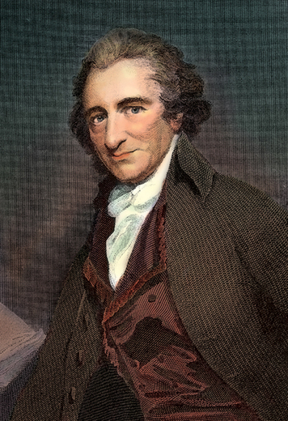
Click to read caption
In January 1776, the pamphlet Common Sense was published in Philadelphia. The document caused an immediate sensation. In powerful language, the writer Thomas Paine made a compelling case for separation from Great Britain. Paine had not been in the colonies for long. But his call for an end to British rule would help pave the way for American independence.
On November 30, 1774, the ship London Packet arrived in the port of Philadelphia. On board was a 37-year-old Englishman named Thomas Paine. Paine was not even aware that he had landed in America. He was burning up with fever and was barely conscious. He had caught the deadly disease typhus, which had already killed several people on board.
At the time, disease was just one of the perils of travel across the Atlantic. Violent storms, collisions with icebergs, and pirate attacks were other hazards. One ship took so long to cross the ocean that the food ran out and many of the passengers starved to death.
Paine was lucky to be alive, but he was still very ill. Unable to walk, he was carried ashore in a blanket. A local doctor agreed to nurse him back to health.
It was not a promising start to life in America. But then, not very much in Paine’s life had gone well. He had held—and lost—a number of different jobs. He had been a craftsman, a teacher, a tax collector, and a shopkeeper. In the end, though, he had little to show for his efforts. He had no money and few prospects. But he did have one important asset for his new life: letters of introduction from Benjamin Franklin.
Paine had met Franklin in London and had impressed him with his sharp mind and his interest in science and politics. Franklin encouraged Paine to move to Pennsylvania and gave him letters of reference, calling him “an ingenious, worthy young man.” These letters would help Paine start a new life.
Paine Finds His Calling
Paine had arrived in the largest and most prosperous city in colonial America. Philadelphia was a bustling place of around 30,000 people and the third largest port in the British Empire. Set along the banks of the Delaware River, Philadelphia was the financial and cultural capital of the colonies. It was also a center of political activity. In fact, the Continental Congress had held its first meeting there not long before Paine’s arrival. The city was buzzing with talk of politics.
With the help of Franklin’s introduction, Paine soon landed a job as the editor of a new magazine. He had already done some writing in England. But it was here that he discovered his true calling as a writer. Paine soon made his publication, Pennsylvania Magazine, the most widely read magazine in the colonies.
Magazines were fairly new at the time. But along with pamphlets, they were becoming increasingly popular. They were quicker and cheaper to publish than books, and that kept their price low. They also offered the space to cover issues in greater detail than newspapers could. This made them appealing to a public that had a growing appetite for information.
At first, Paine wrote articles mainly about cultural and scientific subjects. But he soon moved on to political topics. Paine’s years as a tax collector had left him with no love for the British government. His articles criticized British officials and colonial rule. These stories did not please the Loyalist citizens of Philadelphia, who favored strong ties to Great Britain. On the other hand, they did appeal to readers with Patriot sympathies.
One of these readers was Benjamin Rush, a doctor who would later play a key role in the independence struggle. Rush encouraged Paine to write a pamphlet on independence, though he cautioned him not to use that word. The idea of independence made many colonists uneasy. They might complain about British rule, but the prospect of separating from Great Britain scared them. It did not scare Paine, though. In October 1775, he began working on the essay he would call Common Sense.
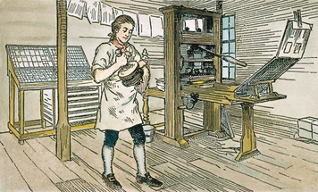
Click to read caption
An Appeal to Common Sense
By December, Paine had finished his essay. But he had trouble getting it published. The subject of independence was just too hot for many publishers to handle. As Paine noted at the time, colonists were so attached to Great Britain that it was “a kind of treason to speak against it.”
Eventually, however, Paine found a publisher who agreed to print a thousand copies as a pamphlet. It was 46 pages long. The pamphlet did not have Paine’s name on the cover, but simply said, “written by an Englishman.” On January 10, 1776, Common Sense appeared in bookstores.
What happened next was astonishing. The first edition sold out in days. Paine had more copies printed, and those sold out, too. Within a few months, readers had bought more than 120,000 copies of Common Sense. By the end of the year, 25 editions had been printed. Hundreds of thousands of copies were in circulation throughout the colonies. It is estimated that as many as half of all colonial citizens had either read the pamphlet or had it read to them. Common Sense was a runaway success. And Thomas Paine was America’s first bestselling author.
What explains this stunning result? Evidently, Paine had touched a nerve. The public was not as resistant to the idea of independence as he and others had feared. Paine’s success lay in his ability to present separation as logical and reasonable, as a matter of common sense. He used language that was direct, clear, and powerful. Drawing on the shared experience of colonists, he built a persuasive case for independence. “The sun never shined on a cause of greater worth,” he wrote.
’Tis not the affair of a city, a country, a province, or a kingdom, But
of a continent . . . ’Tis not the concern of a day, a year, or an age . . .
Now is the seed-time of continental union, faith, and honor.
One reader in Connecticut wrote, “You have declared the sentiments of millions . . . We were blind, but on reading these enlightening words the scales have fallen from our eyes.”
Paine recognized that the main obstacle to independence among colonists was their continued loyalty to the king and crown. So he set out to demolish that loyalty. As one Paine biographer wrote, “Common Sense could be considered the first American self-help book, the help being for those who could never imagine life without a monarch.”
Paine began by ridiculing the notion that kings had some special, God-given right to rule over their subjects. He called the king the “royal brute of England” and said, “Even brutes do not devour their young, nor savages make war upon their families.” He linked the problems of life in the colonies to the evils of British rule and argued that Americans would be much better off on their own. “Everything that is right or natural pleads for separation,” he declared. “The blood of the slain, the weeping voice of nature cries, ’tis time to part.”
Paine argued that the colonists should unite around a common goal, to create a self-governing nation based on principles of liberty. “We have it in our power to begin the world over again,” he wrote. “The birthday of a new world is at hand.” And in one stirring passage, he called on America to make itself the refuge of freedom:
Every spot of the old world is overrun with oppression.
Freedom hath been hunted round the globe. Asia and Africa have long
expelled her. Europe regards her like a stranger, and England
hath given her warning to depart. O! receive the fugitive, and
prepare in time an asylum for mankind.
The Impact of Common Sense
Although Paine’s words were powerful, his ideas were not new. Many other colonial leaders, such as Benjamin Franklin, Thomas Jefferson, and John Adams, had expressed similar thoughts. But Paine was able to put those ideas together in a single, compelling argument that spoke to a mass audience. As Benjamin Rush noted, the ideas that Paine put forth in Common Sense had previously lain “like stones in a field, useless ’til collected and arranged in a building.”
Common Sense did not start the movement for independence. That movement had been building for some time. Nor did it cause colonial leaders to declare independence. Another six months would pass before the Declaration of Independence was issued. But Paine’s work opened up the debate on separation from Great Britain. It helped many colonists see independence as a real possibility.
Paine’s ideas on rights and liberty also had an influence on other countries, particularly France. In fact, Paine later moved to France to play a role in the French Revolution. He also wrote several books, including The Rights of Man. But none of his other works would have quite the impact as Common Sense, the pamphlet that helped pave the way for American independence.

1. Preparing to Write: Identifying a Theme

- Common Sense was a best seller from the minute it was published. Historians say that half of all colonists read it or had it read to them. (If a book were published today and half the U.S. population read it, that would be more than 150 million people!)

- Suppose you had a chance to publish Common Sense today. What would you put on the cover of your pamphlet to entice people to buy it? Design a front cover for the pamphlet. Include these elements:
• the title
• the author’s name
• the date of first publication
• a simple drawing that reflects the pamphlet’s theme

2. Writing Copy for a Cover

Now write the text for the pamphlet’s back cover. Include these elements in your copy:
• a two-sentence description of the author
• a paragraph explaining why Paine’s ideas seem to be “common sense”

