GEOGRAPHY CHALLENGE-A DIVIDING NATION
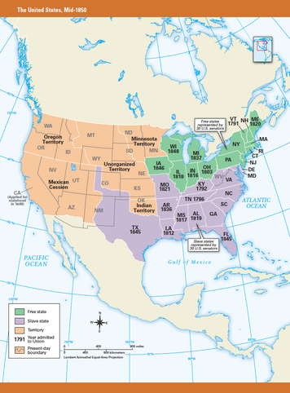
The maps on these two pages show the United States in mid-1850, the year tensions over slavery reached a breaking point. In this unit, you will learn why this crisis developed and how Congress handled it. You will also learn about events after 1850 that further divided the North and South and turned the dispute over slavery into war.
As the map above shows, some states allowed slavery. Notice, however, that the same number of states banned it. This balance gave the slave states and the free states an equal number of votes in the U.S. Senate. However, as the map on this page shows, that equality did not exist in the House of Representatives, where each state’s votes are based on its population.
The Constitution requires that the House and Senate agree on new laws. Southerners believed that as long as the Senate remained balanced, Congress could not pass laws to affect slavery. Then, in 1849, California asked to become a state. California’s new constitution, however, banned slavery. Admitting California as a free state, many Southerners warned, would upset the equal balance between slave states and free states—making the slave states a minority.
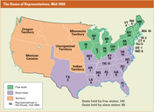

The 1850s were one of the most troubled decades in U.S. history. Yet, they were mild compared to the 1860s, a time of war, bitterness, and the repair of a broken nation. As you explore the topics in this unit, picture what it must have been like to live during such difficult times. The era’s events drew the American people into a deadly struggle over slavery, freedom, and the very survival of the nation.

