. Introduction
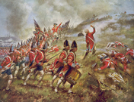
Click to read caption
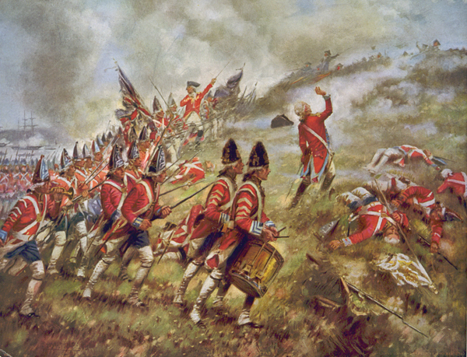
Library of Congress
This painting shows British troops in battle during the American Revolution. Compare this painting to the one on the opposite page. What differences do you see between the soldiers in these two armies?
When the American war for independence from Great Britain began in 1775, 15-year-old Joseph Martin was too young to join the Continental army. But when recruiters returned to his Connecticut village a year later, he was ready to go.
The recruiters were looking for volunteers to go to New York, where the British were rumored to have 15,000 troops. “I did not care if there had been fifteen times fifteen thousand,” Martin said later. “I never spent a thought about numbers. The Americans were invincible, in my opinion.”
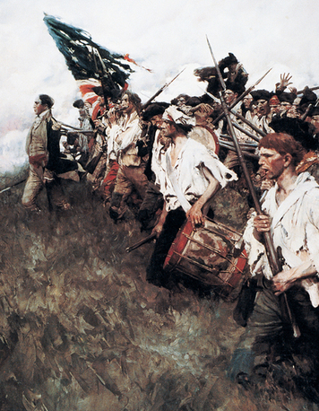
Click to read caption
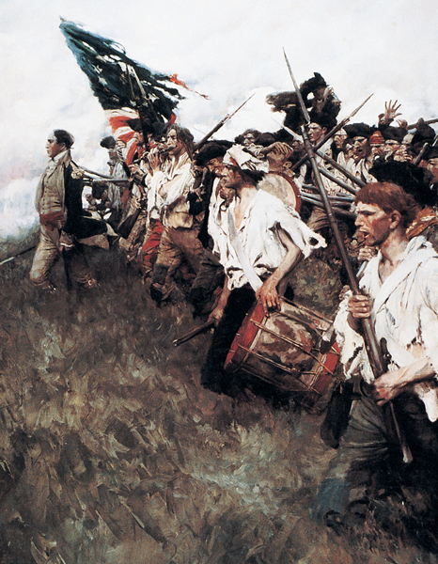
The Granger Collection, New York
This painting shows American soldiers at the Battle of Brandywine in 1777 during the war for independence from Great Britain.
Just two days after the Declaration of Independence was signed, Martin traded his plow for a musket, an early type of rifle. A week later, he arrived in New York City, where he hoped to “snuff [sniff] a little gunpowder.” As he recalled, “I was now, what I had long wished to be, a soldier; I had obtained my heart’s desire; it was now my business to prove myself equal to my profession.
If Martin had known what lay ahead, he might not have been so pleased about his new profession. The army in New York was ill trained, ill equipped, and just plain ill. “Almost the whole regiment are sick,” reported a Massachusetts officer of his unit.
The British army, in contrast, was well trained, well equipped, and well supported by the British navy. Rather than the 15,000 troops Martin had heard of, the British had assembled a force of 25,000 men in New York. More than 400 British ships floated in the harbor. This was the biggest army and the largest fleet the British had ever sent overseas.
In the face of such overwhelming force, the Americans should have been easily defeated. But they were not. In this chapter, you will read how soldiers like Joseph Martin stood up to mighty Great Britain in a successful revolution that created a new nation.
- 1. Suppose you were choosing members of a team for the game Capture the Flag. List the three characteristics or skills you think would be most important to look for.
- 2. Suppose you have a team of Capture the Flag players who have most of the characteristics and skills you listed above playing against a team with very few of those skills. Which team do you think would win and why?
- 3. What other factors might give the team with fewer skills a chance to win?

2. American Strengths and Weaknesses

- 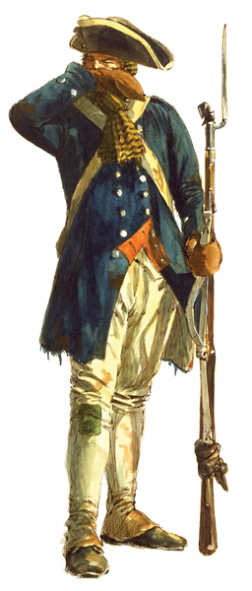
Getty Images
At the beginning of the war, American soldiers were poorly trained and poorly equipped. They lacked gunpowder, rifles, food, and clothing. Some men had only spears or axes for weapons.
The Patriots were in a weak position when the American Revolution [American Revolution: the struggle of the colonies in North America to gain their independence from Great Britain] began. They had a hastily organized, untrained army and a small navy. Their weaknesses were far more obvious than their strengths.
American Weaknesses The Continental army [Continental army: the American army during the American Revolution] was always short of men. General George Washington never had more than 20,000 troops at one time and place. Many soldiers enlisted for six months or a year. Just when they were learning how to fight, they would pick up their muskets and go home to take care of their farms and families.
Few Americans were trained for battle. Some were hunters and could shoot well enough from behind a tree. But when facing a mass of well-disciplined redcoats, they were likely to turn and run.
The army was plagued by shortages. Guns and gunpowder were so scarce that Benjamin Franklin suggested arming the troops with bows and arrows. Food shortages forced soldiers to beg for handouts. Uniforms were scarce as well. In winter, one could track shoeless soldiers by their bloody footprints in the snow.
Such shortages outraged Washington. But when he complained to the Second Continental Congress, nothing changed. Congress, the new nation’s only government, lacked the power to raise money for supplies by taxing the colonies—now the new nation’s states.
In desperation, Congress printed paper money to pay for the war. But the value of this money dropped so low that merchants demanded to be paid in gold instead. Like everything else, gold was scarce.
American Strengths Still, the Americans did have strengths. One was the patriotism of people like Joseph Martin, who willingly gave their lives to defend the ideal of a country based on liberty and democracy [democracy: a system of government in which the power to govern belongs to the people] . Without them, the war would have been quickly lost.
The Americans also received help from overseas. Motivated by their old hatred of the English, the French secretly aided the Americans. During the first two years of the war, 90 percent of the Americans’ gunpowder came from Europe, mostly from France. In addition, a Polish Jew named Haym Salomon, who immigrated to New York in 1775, helped to finance the war effort.
The Americans’ other great strength was their commander. General Washington was more than an experienced military leader. He was also a man who inspired courage and confidence. In the dark days to come, it was Washington who would keep the ragtag Continental army together.

3. British Strengths and Weaknesses
In contrast to the American colonies, Great Britain entered the war from a position of strength. Yet, despite both their real and their perceived advantages, the British forces encountered many problems.

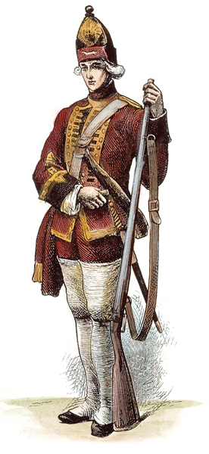
The Granger Collection, New York
British soldiers were trained professionals. They were well equipped with plenty of ammunition, good muskets, adequate food, and uniforms.
British Strengths With a professional army of about 42,000 troops at the beginning of the war, British forces greatly outnumbered the Continental army. In addition, George III hired 30,000 mercenaries from Germany. These hired soldiers were known as Hessians (HEH-shenz) because they came from a part of Germany called Hesse-Cassel. The British were also able to recruit many Loyalists, African Americans, and American Indians to fight on their side.
British and Hessian troops were well trained in European military tactics. They excelled in large battles fought by a mass of troops on open ground. They also had far more experience firing artillery than Americans had.
The British forces were well supplied, as well. Unlike the pitifully equipped Continental army, they seldom lacked for food, uniforms, weapons, or ammunition.
British Weaknesses Even so, the war presented Great Britain with huge problems. One was the distance between Great Britain and America. Sending troops and supplies across the Atlantic was slow and costly. News of battles arrived in England long after they had occurred, making it difficult for British leaders to plan a course of action.
A second problem was that King George and his ministers were never able to convince the British people that defeating the rebels was vital to the future of Great Britain. The longer the war dragged on, the less happy the British taxpayers became about paying its heavy costs.
A third problem was poor leadership. Lord George Germain, the man chosen to direct the British troops, had no real sense of how to defeat the rebels. How could he? He had never set foot in North America. Nor did it occur to him to go see for himself what his army was up against. If he had, Germain might have realized that this was not a war that could be won by conquering a city or two.
To end the revolution, Germain’s forces would have to crush the Patriots’ will to fight, state by state. Instead, Germain kept changing plans and generals, hoping that some combination of the two would bring him an easy victory.
1. List at least two strengths and two weaknesses of each side at the start of the war for independence.
• American Strengths:
• American Weaknesses:
• British Strengths:
• British Weaknesses:

4. Great Britain Almost Wins the War

Click to read caption
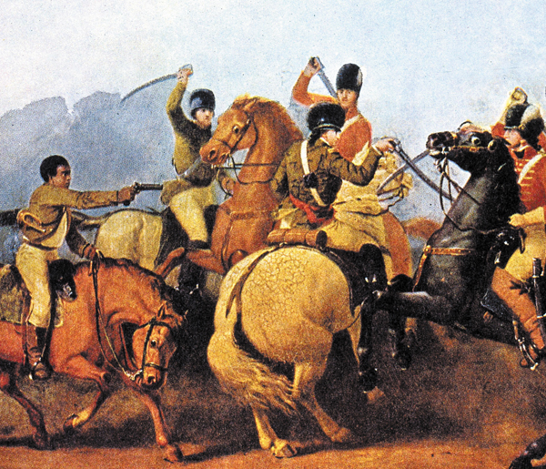
Getty Images
African Americans faced a difficult decision during the revolution. Which country was more likely to give them freedom at the end of the war, America or Great Britain? Many blacks chose to fight with the Americans. With their help, the Continental army defeated the British at the Battle of Cowpens in South Carolina, pictured below.
After the British abandoned Boston in the spring of 1776, Germain came up with his first plan for winning the war. British forces in America, led by General William Howe, were ordered to capture New York City. From that base, British troops would then move north to destroy the rebellion [rebellion: a violent attempt to resist or overthrow the government or another authority] at its heart: Massachusetts.
To block the British invasion, Washington hurried with his army from Boston to New York. It was there that he heard the good news: by signing the Declaration of Independence, Congress had finally declared the colonies to be “free and independent states.”
Washington had the Declaration of Independence read aloud to his troops. The time had come, he said, to “show our enemies, and the whole world, that free men, contending for their own land, are superior to any mercenaries on Earth.” The Declaration made it clear that the troops had the support of all the colonies, who agreed that independence was a prize worth fighting for.
African Americans and the War For African Americans, however, the Declaration of Independence raised both hopes and questions. Did Jefferson’s words “all men are created equal” apply to them? Would independence bring an end to slavery? Should they join the revolution?
Even before independence was declared, a number of African Americans had joined the Patriot cause. Black militiamen, both free and slave, fought at Lexington, Concord, and Bunker Hill. Early in the war, however, blacks were banned from the Continental army. Washington did not want the army to become a haven for runaway slaves.
In contrast, the British promised freedom to all slaves who took up arms for the king. As a result, thousands of runaways became Loyalists and fought for Great Britain.
A shortage of volunteers soon forced Washington to change his mind. By 1779, about 15 percent of the soldiers in the Continental army were African Americans. Large numbers of black sailors also served in the Continental navy.
As black Americans joined the war effort, some whites began to question their own beliefs. How could they accept slavery if they truly believed that all people are created equal, with the same rights to life, liberty, and happiness? By the war’s end, Vermont, Connecticut, Massachusetts, New Hampshire, Rhode Island, and Pennsylvania had all taken steps to end slavery.
Defeat in New York On August 27, 1776, the American and British armies met in Brooklyn, New York, for what promised to be a decisive battle. The Americans began their defense of the city in high spirits. But the inexperienced Americans were no match for the British, with their greater numbers and superior training. In two days of fighting, the British lost only 377 men, while the Americans lost 1,407.
Satisfied that the war was nearly won, Howe ordered a halt to the British attack. Washington, he assumed, would do what any self-respecting European general would do in a hopeless situation. He would surrender honorably. And so Howe waited.
Washington had no intention of giving up. But for his army to survive, he would have to retreat. Even though Washington knew this, he could not bring himself to utter the word retreat.
An officer named Thomas Mifflin rescued him from his pride. “What is your strength?” Mifflin asked. “Nine thousand,” Washington replied. “It is not sufficient,” said Mifflin bluntly. “We must retreat.”
Fading Hopes The battle for New York City was the first of many defeats for the Americans. In the weeks that followed, British forces chased the Americans out of New York, through New Jersey, and finally across the Delaware River into Pennsylvania.
For Joseph Martin and his comrades, this was a trying time. There was little food to eat, and the soldiers grew weak from hunger. As the weather turned cold, muddy roads and icy streams added to their misery. With their terms of enlistment nearly up, many soldiers headed for home. Along the way, they spread the word that anyone who volunteered to risk his life in the Continental army had to be crazy.
By the time Washington reached Pennsylvania, only a few thousand men were still under his command. Many of his remaining troops, he reported, were “entirely naked and most so thinly clad [clothed] as to be unfit for service.” More troops had to be found, and found quickly, he wrote his brother. Otherwise, “I think the game will be pretty well up.”
- 1. Why did the Declaration of Independence increase Americans’ motivation to fight and win the war?
- 2. For which group of Americans did the Declaration of Independence raise hopes as well as questions? Why?

5. Pep Talk and Surprise Victories

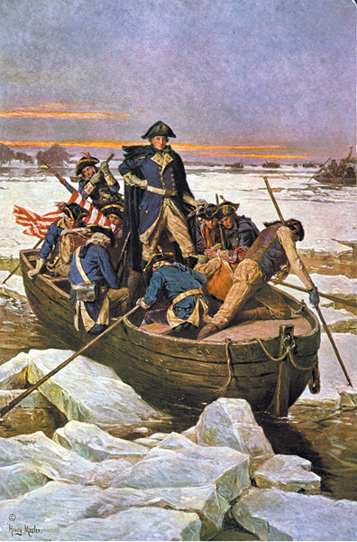
Library of Congress
With morale low and his soldiers threatening to return home, George Washington planned a daring attack on the Hessians at Trenton. Crossing the ice-choked Delaware River at night, he surprised the enemy, overwhelming them completely.
By the end of 1776, the British also thought the war was just about over. General Howe offered to pardon all rebels who signed a statement promising to “remain in peaceful obedience” to the king. Thousands took him up on his offer.
The Crisis Washington knew he had to do something—quickly. Gathering his last troops together, he read to them from Thomas Paine’s new pamphlet, The Crisis.
These are the times that try men’s souls. The summer soldier and the sunshine patriot will, in this crisis, shrink from the service of their country; but he that stands it now, deserves the love and thanks of man and woman.
Next, Washington outlined a daring plan to attack Hessian troops who were camped for the winter in Trenton, New Jersey. Heartened by Thomas Paine’s words, his men did not “shrink from the service of their country.”
Victory in Trenton Late on December 25, 1776, Washington’s army crossed the ice-choked Delaware River in small boats. On the New Jersey shore, Washington gave his men the password for the long nighttime march ahead: “Victory or death.”
As the American troops made their way toward Trenton, a driving snow chilled them to the bone. Ice and rocks cut through their worn-out shoes. One officer reported to Washington that the troops’ guns were too wet to fire. “Use the bayonets,” the general replied. “The town must be taken.”
When the Americans reached Trenton, they found the Hessians happily sleeping off their Christmas feasts. Caught completely by surprise, the mercenaries surrendered. Washington took 868 prisoners without losing even a single man. A week later, the Americans captured another 300 British troops at Princeton, New Jersey. These defeats convinced Howe that it would take more than capturing New York City and issuing [issuing: to supply or make available] pardons to win the war.
News of Washington’s victories electrified Patriots. “A few days ago they had given up their cause for lost,” wrote an unhappy Loyalist. “Their late successes have turned the scale and they are all liberty mad again.” The game was not yet up.

- 1. In your own words, what was the message of Thomas Paine’s pamphlet The Crisis?
- 2. How were the Americans able to win such an overwhelming victory at Trenton?
- 3. How did victories at Trenton and Princeton affect American morale?

6. The Tide Begins to Turn
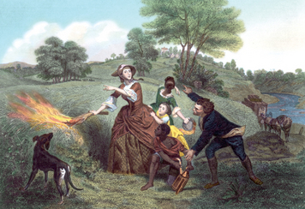
Click to read caption

Library of Congress
Catherine Schulyer was the wife of Philip Schulyer, a major general in the Continental army and a member of the Continental Congress. They lived near Albany, in the path of British forces advancing toward Saratoga. To leave nothing useful for the British, Catherine burned the family wheat fields.
When the American Revolution began, both sides adopted the same military strategy [strategy: an overall plan, such as for winning a war] , or overall plan for winning the war. That strategy was to defeat the enemy in one big battle.
After barely escaping from his loss in New York, Washington revised his strategy. In the future, he wrote Congress, he would avoid large battles that might put his army at risk. Instead, the war would be “defensive.” Rather than defeating the British, Washington hoped to tire them out.
A New British Strategy Germain revised the British strategy as well. His new plan was to divide the rebels by taking control of New York’s Hudson River Valley. Control of this waterway would allow the British to cut New England off from the rest of the states. Without men and supplies from the New England states, the Continental army would surely collapse.
To carry out this plan, General John Burgoyne (ber-GOIN) left Canada in June 1777 with about 8,000 British soldiers and American Indian warriors. He planned to move this army south to Albany, New York. There he would meet up with General Howe, who was supposed to march his army north from New York City.
Problems with Burgoyne’s Plan There were two big problems with Burgoyne’s plan. The first was that what looked like an easy invasion route on a map was anything but easy. The route Burgoyne chose from Canada to Albany took his army through more than 20 miles of tangled wilderness. His army had to build bridges, chop down countless trees, and lay out miles of log roads through swamps as it crept toward Albany.
To make matters worse, Burgoyne didn’t travel light. His army was slowed by more than 600 wagons, 30 of them filled with his personal baggage. Even in the wilderness, “Gentleman Johnny” Burgoyne sipped champagne with his supper.
The second problem with Burgoyne’s plan was that General Howe had his own ideas about how to win the war. Instead of marching to Albany, Howe headed for Philadelphia, the rebels’ capital. There he hoped to lure Washington into another major battle. Howe hoped it would be the last one.
Washington, however, refused to risk his army in another big battle. He would not fight for Philadelphia. Instead, he played hide-and-seek with Howe, attacking here and there and then disappearing into the countryside.
A Turning Point By the time the slow-moving Burgoyne finally reached Saratoga Springs on the Hudson River, the area was swarming with militia. Although the rebels outnumbered his army, Burgoyne ordered an attack. Again and again the rebels beat back Burgoyne’s troops. On October 17, 1777, Burgoyne accepted defeat.
Burgoyne’s surrender marked a turning point in the war. Before the victory at Saratoga, most of the world believed that the American cause was hopeless. Now the Americans had shown they could stand up to a British army and win.
Not long after this victory, France came into the war as an ally [ally: a nation that joins another nation in some common effort, such as fighting a war] of the United States. The French government sent money, weapons, troops, and warships to the Americans. Spain also entered the war against Great Britain. The American cause no longer looked quite so hopeless.
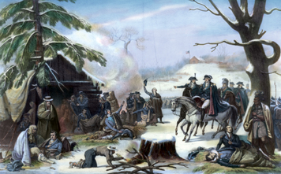
Click to read caption

Library of Congress
George Washington is shown at right with the Marquis de Lafayette at Valley Forge. Lafayette, a Frenchman who aided the Americans, described the American soldiers there as “in want of everything; they had neither coats, nor hats, nor shirts nor shoes; their feet and their legs froze until they grew black.”
Winter at Valley Forge Saratoga was a stunning victory, but the war was far from over. While General Washington’s army roamed the countryside, Howe’s forces still occupied Philadelphia.
Late in 1777, Congress declared a day of thanksgiving for the army’s successes. By this time, Washington and his army were on their way to Valley Forge, Pennsylvania, to make camp for the winter. Joseph Martin described the army’s “celebration”:
We had nothing to eat for two or three days previous . . . But we must now have what Congress said, a sumptuous [lavish] Thanksgiving . . . It gave each and every man a gill [a few ounces] of rice and a tablespoon of vinegar! The army was now not only starved but naked. The greatest part were not only shirtless and barefoot, but destitute of [without] all other clothing, especially blankets.
Washington’s troops were hungry because many farmers preferred to sell food to the British. The British paid them in gold, whereas Congress paid them in paper money. As for uniforms and blankets, merchants had raised the prices for these items sky-high. This desire for profits at the army’s expense outraged Washington. “No punishment,” he fumed, “is too great for the man who can build his greatness upon his country’s ruin.”
To help lift his men from their misery, Washington put Baron Friedrich von Steuben (FREE-drik von STU-bin) in charge of training. A military officer from Prussia (in modern-day Germany), von Steuben arrived in December 1777 and set to work turning the Continental army into an organized fighting force. The Prussian’s method, wrote Martin, was “continual drill.” It worked wonders. “The army grows stronger every day,” wrote one officer. “There is a spirit of discipline among the troops that is better than numbers.”
Another foreign volunteer, the Marquis de Lafayette (mar-KEE duh la-fey-ET), also helped raise the troops’ spirits. Although he was one of the richest men in France, Lafayette chose to share the hardships of Valley Forge. He even used his own money to buy the men warm clothing. “The patient fortitude [courage] of the officers and soldiers,” Lafayette wrote, “was a continual miracle.”
When at last spring arrived, Washington received news that the British were about to abandon Philadelphia. The time had come to put his newly trained army to the test.
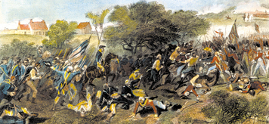
Click to read caption

The Granger Collection, New York
While chasing the retreating Continental army, British soldiers looted the homes of Americans, both Patriots and Loyalists. Such actions turned many former supporters into enemies.
The Battle of Monmouth By this time, Sir Henry Clinton had replaced General Howe as commander of the British forces in North America. In Clinton’s view, taking over Philadelphia had gained the British nothing. He ordered his army to retreat to New York City, where the Royal Navy could keep it supplied by sea.
Now it was Washington’s turn to chase an army across New Jersey. On June 28, 1778, he caught up with the retreating British near Monmouth, New Jersey. In the battle that followed, Washington seemed to be everywhere, constantly rallying his men to stand and fight. “Cheering them by his voice and example,” wrote Lafayette, “never had I beheld [seen] so superb a man.”
Late that night, the British slipped across the Hudson River to safety in New York City. Washington camped with his army nearby. It was pleasing, he wrote, “that after two years maneuvering . . . both armies are brought back to the very point they set out from.” Neither army knew it yet, but the war in the North was over.
- 1. As the war progressed, how did General Washington revise his military strategy?
- 2. Why did the American cause look more hopeful after the Battle of Saratoga?

Click to read caption
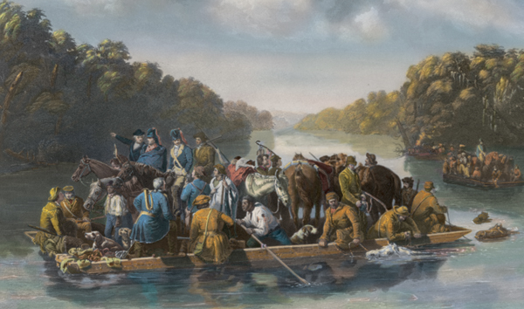
Library of Congress
7. The War Moves South
This engraving shows Francis Marion crossing the Pee Dee River in South Carolina. Marion, known as the “Swamp Fox” because of his tactic of ambushing the British from the marshes of the South, never led a force of more than 70 men.
After failing to conquer any state in the North, the British changed strategies yet again. Their new plan was to move the war to the South. There, they believed, thousands of Loyalists were just waiting to join the king’s cause.
Clinton began his “southern campaign” with a successful attack on Savannah, Georgia. From Georgia, he moved north to take control of North and South Carolina. At that point, Clinton returned to New York City, leaving Lord Charles Cornwallis to control the war in the South.
Saving the South Cornwallis soon learned that he did not really control the Carolinas after all. Guerrillas—soldiers who are not part of a regular army—kept the American cause alive. One of them was Francis Marion, who was also known as the “Swamp Fox.” Marion’s band of rebels harassed the British with hit-and-run raids. They attacked and then faded into the swamps and forests like foxes.
Late in 1780, Washington sent General Nathanael Greene to slow the British advance through the South. Greene’s army was too small to meet Cornwallis in a major battle. Instead, Greene led Cornwallis’s troops on an exhausting chase through the southern backcountry. He wrote of his strategy, “We fight, get beat, rise, and fight again.”
Greene’s strategy worked wonderfully. In April 1781, Cornwallis wrote that he was “quite tired of marching about the country.” He moved his army to Yorktown, a sleepy tobacco port on Chesapeake Bay in Virginia, for a good rest.

Click to read caption
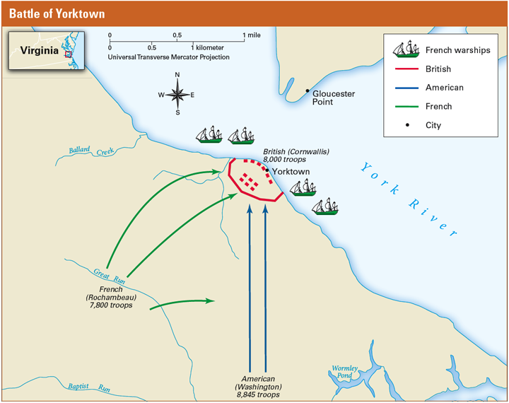
Three groups—the British, the Americans, and the French—were involved in the Battle of Yorktown. The Americans, with the aid of the French, were able to surround the British by using forces on both land and sea.
A Trap at Yorktown By the time Cornwallis was settling into Yorktown, France had sent nearly 5,000 troops to join Washington’s army in New York. In August, Washington learned that another 3,000 troops were scheduled to arrive soon in 29 French warships.
Washington used this information to set a trap for Cornwallis. Secretly, he moved his army south to Virginia. When they arrived, they joined the French and surrounded Yorktown on land with more than 16,000 troops.
Meanwhile, the French warships showed up just in time to seal off the entrance to Chesapeake Bay. Their appearance was crucial [crucial: very important or necessary] to the American victory. Now Cornwallis was cut off from the British navy and any hope of rescue by sea.
The trap was sprung on October 6, 1781. Joseph Martin watched as a flag was raised to signal that American and French gunners should open fire on Yorktown. “I confess I felt a secret pride swell in my heart,” he wrote, “when I saw the ‘star-spangled banner’ waving majestically.” The shelling went on for days, until “most of the guns in the enemy’s works were silenced.”

Click to read caption
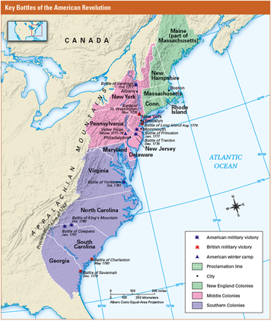
This map shows key battles of the American Revolution. In the early part of the war, major battles took place mostly in the New England Colonies and the Middle Colonies, in the north. As the war continued, battles moved southward. In which colony and region did the Battle of Princeton take place? In which colony and region did the Battle of Yorktown take place?
Cornwallis Surrenders At first Cornwallis clung to the hope that the British navy would come to his rescue, even as Yorktown was exploding around him. When no ships arrived, he finally agreed to surrender.
On October 19, 1781, American and French troops formed two long lines that stretched for more than a mile along the road to Yorktown—the French on one side and the Americans on the other. The two lines could not have looked more different. The French were dressed in elegant uniforms that gleamed with gold and silver braid in the afternoon sun. The Americans’ uniforms—and not everyone even had uniforms—were patched and faded. Behind the lines stood civilians who had traveled for miles to witness the surrender.
After hours of waiting, the crowd watched as 8,000 British troops left Yorktown to lay down their arms. The defeated troops moved “with slow and solemn step.” They were accompanied by a slow tune known as “The World Turned Upside Down.” This same sad tune had been played at Saratoga after the British surrender.
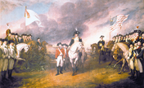
Click to read caption

The Granger Collection, New York.
This painting by John Trumbull shows the British surrender at Yorktown. At the center is General Benjamin Lincoln leading the British. General Washington is on the right, in front of the American fl ag. On the left are French, Polish, and Prussian soldiers.
Cornwallis did not take part in this ceremony, saying that he was ill. In reality, the British commander could not bear to surrender publicly to an army that he looked down on as “a contemptible and undisciplined rabble [mob].” While Cornwallis sulked in his tent, his men surrendered their arms. Many of them wept bitter tears.
To the watching Americans, there was nothing sad about that day. “It was a noble sight to us,” wrote Martin, “and the more so, as it seemed to promise a speedy conclusion to the contest.”

- 1. What tactics did the Americans use successfully against the British in the Southern Colonies?
- 2. How did the success of the Continental army in the South contribute to the American victory?
- 3. How did the French help the Americans in the Battle of Yorktown?

8. The War Ends

Click to read caption
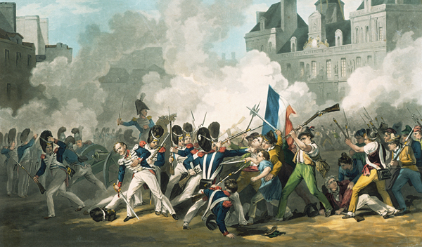
The ideals of the American Revolution inspired calls for “Liberty, equality, and fraternity” in France. France’s support for the war deepened its national debt and caused suffering among its people. In 1789, France’s monarchy was overthrown. This painting shows a violent clash between French commoners and King Louis XVI’s troops during the French Revolution.
The conclusion of the war did not come as quickly as Martin had hoped. When Lord North, the British prime minister, heard about Cornwallis’s defeat at Yorktown, he paced up and down the room repeating, “Oh God! It is all over!” When the British people heard about the defeat, most of them accepted it. The loss at Yorktown drained any remaining support for the war. Still, months dragged by before King George was finally forced to accept that the British had been defeated.
For most Americans, the end of the war was a time for joy and celebration. They had gained the freedom to govern themselves and create their own future. But liberty came at a high price. At least 6,200 Americans had been killed in combat. An estimated 10,000 died in camp of diseases, and another 8,500 died while in captivity as British prisoners. As a proportion of the total population, more Americans died fighting in the American Revolution than in any other conflict except the Civil War, in which Americans fought one another.
The Treaty of Paris Early in 1783, representatives of the United States and Great Britain signed a peace treaty in Paris. The Treaty of Paris had three important parts. First, Great Britain agreed to recognize the United States as an independent nation. Second, Great Britain gave up its claims to all lands between the Atlantic Coast and the Mississippi River, from the border of Canada south to Florida. Third, the United States agreed to return all rights and property taken from Loyalists during the war.
Many Loyalists did not trust the treaty’s promise of fair treatment —and for good reason. During the war, Loyalists had been treated badly by Patriots. More than 80,000 Loyalists, both black and white, left the United States to settle in British Canada.
The Impact of the American Revolution The American Revolution had a major impact in other parts of the world. In Europe, it thrilled liberals who dreamed of creating their own democracies. The American example was especially influential in France, which soon had its own revolution. As one Frenchman wrote, “They [Americans] are the hope of the human race; they may well become its model.” Indeed, in the 1800s, that model would help inspire revolts against European rule in South America.
- 1. How did the British people and the king respond to news of the Battle of Yorktown?
- 2. What were three key provisions of the Treaty of Paris?
- 3. Give two examples of how the American Revolution affected other parts of the world.

In this chapter, you read how the American colonies won their independence from Great Britain.
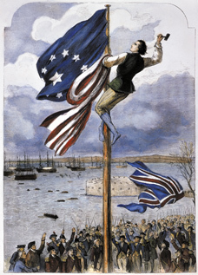
Click to read caption

Library of Congress
The war officially ended with the signing of the Treaty of Paris in 1783. British troops agreed to leave American soil “with all convenient speed.”
American Strengths and Weaknesses The Continental army was short of men, and few men were trained for battle. The Americans also lacked adequate weapons and food. Their strengths included patriotism, support from France, and Washington as their military leader.
British Strengths and Weaknesses British troops greatly outnumbered American troops and were better trained and equipped. Sending troops and supplies to the colonies was slow and costly. The British also had poor leadership and a lack of support from people at home.
Great Britain Almost Wins the War The British won a series of victories early in the war. After the loss of New York City, only Washington’s leadership kept the colonists going.
A Pep Talk and Surprising Victories Thomas Paine’s The Crisis encouraged Americans to keep fighting. Colonial victories at Trenton and Princeton gave new hope for their cause.
The Tide Begins to Turn The colonists’ victory in the Battle of Saratoga in 1777 marked a turning point in the war. Shortly afterward, France and Spain joined the colonies as allies.
The War Goes South The British moved south into Georgia and the Carolinas, but American troops slowed their advance. The British surrendered after the Battle of Yorktown.
The War Ends The conflict ended with the signing of the Treaty of Paris in 1783. Under the terms of the treaty, Great Britain recognized the United States as an independent country.

- 1. Create a simile that shows how the Americas were able to beat the British and win the war for independence.
Step 1: Complete this sentence by rewriting it below: The Continental army’s victory in the American Revolution was like . . . Use one of these examples to complete the sentence, or create your own:
• the class game of Capture the Flag
• David’s victory over Goliath
• the story of the tortoise and the hare
• a recent sports upset
Step 2: Write two “because” statements to explain why your simile is like the Continental army’s victory in the American Revolution.

Reading Further - George Washington: A Warrior Spirit and a Caring Heart
Everyone knows stories about George Washington. From chopping down the cherry tree to helping the nation win independence, the stories make Washington sound larger than life. Washington’s writings reveal a more complex person. Behind his strong public presence was a man of many sentiments. He balanced a deep love of his family with a commitment to fighting for his country. He coupled bravery with concern, caution, and compassion.

Click to read caption
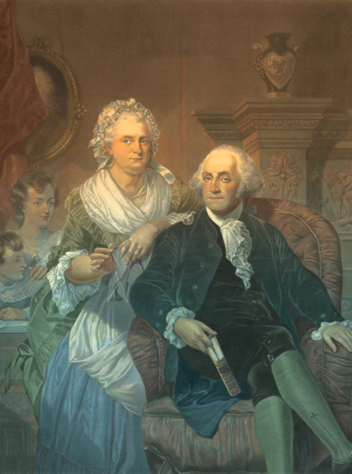
RF/Picture Research Consultants & Archives
George Washington hated to leave his wife, Martha, but he believed in the cause of freedom. So he agreed to lead the colonial war effort.
In 1775, the Continental Congress asked George Washington to lead the colonial army. Washington was living on his estate at Mount Vernon, Virginia, at the time. He had proven his military skills in the French and Indian War. And he had the added benefit of coming from the South. If he were to command the army, Congress thought, he might tie the Southern Colonies more firmly to the cause.
Washington believed deeply in that cause. Still, he had his doubts about taking on the important job Congress offered. Young soldiers like Joseph Plumb Martin, a Connecticut farm boy, looked forward to going to war. But Washington was 43 years old and had fought in wars before. He knew it would be hard to leave his home and family. In a letter to his wife, Martha, he said, “I should enjoy more real happiness in one month with you at home, than I have the most distant prospect of finding abroad [away from home] if my stay were to be seven times seven years.”
Eventually, Washington did lead the colonists to victory, but in 1775, he was not sure he would be able to do so. He worried he would not be clever enough to ensure that the colonists would win the war. He thanked Congress for the honor of being asked to lead. He told them about his concerns, but said he would do everything he could to help the colonists reach their goal. In a speech to Congress, he said,
I feel great distress from a consciousness that my abilities and military experience may not be equal to the extensive and important trust. However, as the Congress desire it, I will enter upon the momentous duty, and exert every power I possess in their service and for the support of the glorious cause.

The Man’s Compassion
Washington was a general, but he understood the hardships his soldiers faced. At the top of the list was low pay. He felt bad that his men had to do so much hard work for so little money. He also knew that low pay kept some men from enlisting. A soldier “cannot ruin himself and family to serve his country,” he told Congress.

Click to read caption
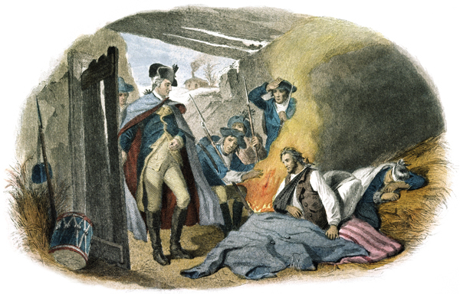
Bettmann/CORBIS
George Washington cared about his soldiers’ suffering. Here he is shown visiting wounded men at Valley Forge during the winter of 1777–78.
Washington witnessed the terrible shortages his soldiers lived with. Joseph Plumb Martin felt the sting of the shortages. He went for days without food and made simple moccasins to keep his feet off the ice. Years later, Martin wrote in his A Narrative of a Revolutionary Soldier (1830) that it was ironic that soldiers for a noble cause were so poorly equipped. He described the soldiers marching through Princeton, New Jersey.
The young ladies of the town . . . had collected and were sitting in the stoops and at the windows to see the noble exhibition of a thousand half-starved and three-quarters naked soldiers pass in review before them.
The soldiers’ suffering upset Washington. He repeatedly asked for more supplies. During the harsh winter at Valley Forge, he wrote to Congress. In a letter dated December 23, 1777, he accused the congressmen of not understanding what his soldiers went through.
I can assure those gentlemen that it is a much easier and less distressing thing to draw remonstrances [listen to protests] in a comfortable room by a good fireside, than to occupy a cold, bleak hill, and sleep under frost and snow, without clothes or blankets. However, although they seem to have little feeling for the naked and distressed soldiers, I feel superabundantly for them, and, from my soul, I pity those miseries, which it is neither in my power to relieve or prevent.

The General’s Concerns
George Washington balanced sympathy for his soldiers with his responsibility as their leader. For example, he knew that soldiers did not want to leave home any more than he did. But his sympathy only went so far. When it came down to it, Washington worried that homesick men made poor soldiers. They threatened his mission. They threatened the colonists’ success. “Men just dragged from the tender scenes of domestic life,” he wrote, were easily scared by the hard life of a soldier. Such soldiers might desert the army and encourage others to desert, too.
The compassionate Washington wanted his soldiers to get paid more. But he still expected them to fight, and fight hard. He scorned their lack of discipline. He was horrified by what happened at the Battle of New York, in 1776.
I found the troops . . . retreating [as fast as possible], and those ordered to support them . . . flying in every direction and in the greatest confusion . . . I used every means in my power to rally and get them into some order, but my attempts were . . . ineffectual. . . On the appearance of a small party of the enemy . . .their disorder increased and they ran away in the greatest confusion without firing a single shot.
The general knew that such chaos would never win the war. He did everything he could to see to it that soldiers who neglected their duties were punished.
Similarly, while Washington sympathized with his soldiers being hungry, as general he prohibited them from stealing food. His reason was practical as much as it was moral. Too often, people killed soldiers who tried to steal from them. He wrote to one of his colonels,
Every attempt of the men to plunder houses, orchards, gardens, etc., [should] be discouraged, not only for the preservation of property and sake of good order, but for the prevention of those fatal consequences which usually follow such diabolical practices.
Of course, the general’s rules were not always obeyed. During the winter at Valley Forge, an officer ordered Joseph Plumb Martin to steal to help keep the soldiers from starving. The work was “not altogether unpleasant,” Martin wrote in A Narrative of a Revolutionary Soldier, but it was definitely stealing. He described it this way.
I had to travel far and near . . . and at all times to run the risk of abuse, if not injury, from the inhabitants when plundering them of their property, (for I could not, while in the very act of taking their cattle, hay, corn and grain from them against their wills, consider it a whit better than plundering—sheer privateering) [stealing under the authority of a government].

Click to read caption
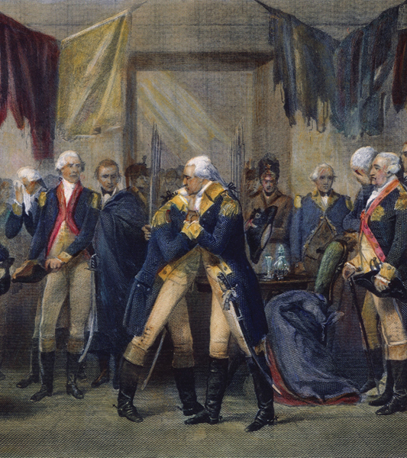
The Granger Collection, New York
George Washington bid an emotional farewell to his offi cers at Fraunces Tavern in New York in 1783. The tavern owner, Samuel Fraunces, was a free black man of French and African descent. He would become chief steward at President Washington’s house in Philadelphia.

Worry and Praise, Courage and Kindness
George Washington worried about his reputation. He wanted people to respect him. But if the colonies lost the war, Washington knew that people would think less of him. That worry gave even the great general cause for concern. He once wrote to his cousin that “I never was in such an unhappy, divided state since I was born.” To a confidant, he wrote that his army service was “one continued round of annoyance and fatigue.”
Nonetheless, Washington kept fighting for the cause of freedom. As the war dragged on, he praised his soldiers for putting up such a good fight against the British, the most powerful army in the world. In a letter, he wrote,
Without arrogance . . . it may be said that no history . . . Can furnish an instance of an army’s suffering such uncommon hardships as ours have done, and bearing them with the same patience and fortitude.
When the war was over, Washington did everything he could to see that the soldiers received fair pay from the new government.
When he said goodbye to his officers, George Washington again balanced courage and kindness. The commander in chief, one general reported, was “suffused in tears.” He could not speak because he had such strong feelings for his men. In the final goodbye, Washington revealed both his warrior spirit and his caring heart.

- Preparing to Write: Choosing Descriptive Words
For all of his fame, George Washington shared many qualities and emotions that we all have. Write five sentences describing George Washington. Use at least one word from the Word Bank in each sentence.
Word Bank
cautious
compassion
concern
emotional
homesick
proud
strict
uncertain
worried
- Writing a Personal Letter
Soldier Joseph Plumb Martin and General George Washington were in the same place a number of times: the Battle of Long Island (1776), Valley Forge (1777–78), the Battle of Monmouth (1778), and the Battle of Yorktown (1781).
At Yorktown, a stranger stopped to talk with Martin and some other soldiers. Martin realized only later that the stranger was the great General Washington. “Had we dared,” Martin wrote, “we might have cautioned him for exposing himself so carelessly to danger at such a time.”
Suppose you had been Joseph Plumb Martin at Yorktown. What would you like to have told General Washington about your experiences in the war? What emotions would you have shared with him? Express your ideas in a short letter that the soldier might have written to the general. Your letter should clearly describe experiences and emotions related to the war. Be sure to use correct letter format and correct spelling and grammar.

Enrichment Essay - Naval Heroes of the American Revolution
The American Revolution (1775–1783) was fought at sea as well as on land. The small Continental navy battled Britain’s powerful Royal Navy in both American and European waters. Let’s meet three commanders who helped lead the American navy to victory.

John Barry
Captain John Barry was born in Ireland in 1745. He came to America in 1760 and settled in Philadelphia, where he became a wealthy and successful shipping captain. In 1776, Congress appointed him to the Continental Navy.
During the Revolutionary War, Captain Barry earned fame for his daring captures of enemy ships. In the spring of 1776, he led one of the Revolution’s first successful sea battles against the British. His ship, the Lexington, captured the heavily armed British ship, the H.M.S. Edward.
In 1777, the British gained control of Philadelphia. Barry successfully attacked the English from the Delaware River. Barry commanded only four small boats. Yet he captured several enemy boats and a large ship full of supplies.
After the war, President George Washington made Barry a commodore (senior captain). As commodore, Barry trained other officers and helped shape the first navy of the United States. Many historians have called Commodore Barry the “Father of the American Navy.”

Nicholas Biddle
Captain Nicholas Biddle was born in 1750 to well-to-do family in Philadelphia. He was just 13 when he went to work on a merchant ship.
In 1772, Biddle joined the British Royal Navy. When the Revolutionary War broke out, he left the Royal Navy to join the American cause.
Biddle’s role in the Revolution was brief but significant. He captured British ships carrying guns, ammunition, and other supplies. Later, despite being outnumbered and outgunned, he captured two English ships carrying 400 soldiers. In 1777, he commanded the Randolph, the Continental navy’s first warship.
In 1778, Biddle led a brave but doomed attack against the British Yarmouth off the coast of South Carolina. The British blew up the Randolph, killing Biddle and all but four of the ship’s 315 men.

John Paul Jones
Captain John Paul Jones became the most famous American naval commander during the Revolution. His original name was John Paul. The son of a gardener, he was born in Scotland in 1747. At the age of 12, Paul worked as a cabin boy on the British ship Friendship. He later worked on a slave ship.
In 1772, Paul bought his own boat. The next year, he killed the leader of a ship rebellion. To avoid standing trial, he ran away to Virginia and changed his name to John Paul Jones.
At the outbreak of the Revolutionary War, Jones was a lieutenant on the Continental navy’s first ship, the Alfred. Although unpopular with other sailors, he was a skillful leader. Congress promoted him to captain in 1776. The following year, Jones sailed to Europe. His actions there made him an American hero.
In 1778, Jones boldly attacked the British in the Irish Sea and along the coast of Scotland. He unsuccessfully tried to burn their ships and kidnap an English nobleman. Jones then attacked and captured the British Drake. He ended his campaign with many prisoners and treasures. Surprised and angered by the attacks, England condemned Jones as a pirate.
Jones’s greatest triumph was the battle of the Bonhomme Richard (Poor Richard) in 1779. The Richard was an old, broken-down ship named after Benjamin Franklin. (Franklin published almanacs under the name Poor Richard.) On September 23, Jones, commanding the Richard, led a small fleet into battle against two enormous new British warships, the H.M.S. Serapis and the Countess of Scarborough.
The gun battle that followed lasted three and a half hours. Jones and his men fought fiercely. When the English demanded that he surrender, Jones declared, “I have not yet begun to fight!”
Despite many deaths and injuries, Jones’s men did not give up. While another ship attacked the Scarborough, Jones pulled the Richard next to the Serapis and tied them together. He and his men boarded the Serapis and attacked the enemy with guns and grenades. The Serapis blew cannon holes into the Richard, but it was too late. As the Richard sank, the British surrendered to Jones and his American fleet. Jones had won his most famous and important sea battle of the war.
After the war, Jones was hailed as a hero throughout the newly formed United States. In 1787, he was the only Revolutionary naval officer to receive a Congressional medal of honor.

- 1. Select one of the naval heroes from the Enrichment Essay. Draw a picture that illustrates the hero’s most famous accomplishment.

