Section 1 - Introduction
When the American war for independence ended, no one was happier than a serious Virginia Patriot named James Madison. And no one was more worried about the future of the United States. While serving in Congress during the war, Madison had tried and failed to get the states to work easily together. He doubted that things would improve now that the war was over.
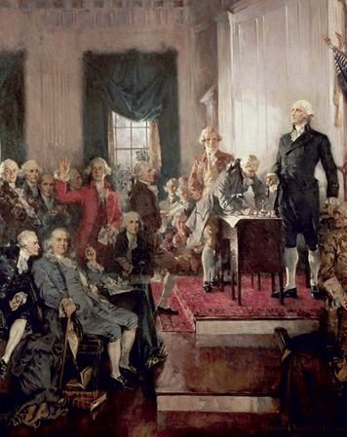
Click to read caption

The Granger Collection, New York.
The Constitution was signed in Philadelphia on September 17, 1787.
After declaring independence in 1776, Congress had tried to unite the states under one national government. This proved to be a difficult task. Most members of Congress were nervous about creating a strong central government. They feared that such a government would trample the very rights they were fighting to preserve.
Their solution was a plan of government known as the Articles of Confederation. The Articles created “a firm league of friendship” in which “each state retains its sovereignty, freedom, and independence.” This “league of friendship” was a loose union in which the 13 states cooperated for common purposes. It was run by Congress, in which each state had one vote.
On paper, the Articles of Confederation gave Congress several important powers. It could declare war, raise an army and a navy, print money, and set up a postal system.
In reality, however, these powers were limited by the inability of Congress to impose taxes. Instead, Congress had to ask the states for funds to do anything. All too often, the states ignored Congress’s “humble requests.” The result, said Madison, was that the Articles were no more effective at binding the states into a nation than “a rope of sand.”
In this chapter, you will read about the new nation’s shaky start under the Articles of Confederation. You will also learn how Madison and other leaders met in 1787 to revise the Articles and ended up compromising to form “a more perfect Union.”

Section 2 - Early Quarrels and Accomplishments
Even before the American Revolution was over, the states began quarreling among themselves. Many of their quarrels were about taxes on goods that crossed state borders. New York, for example, taxed firewood from Connecticut and cabbages from New Jersey. The states also disagreed over boundaries. The inability of Congress to end such disagreements was one of the key weaknesses of the Articles of Confederation [Articles of Confederation: the first written plan of government for the United States. A confederation is an association of states that cooperate for a common purpose.] .
Developing Western Lands Congress did get the states to agree on one important issue: how to develop the western lands acquired in the Treaty of Paris. At that time, there was no orderly way to divide up and sell these lands. Settlers walked into the wilderness and claimed the land they liked. Disputes over who owned what clogged the courts.
To end this confusion, Congress passed the Land Ordinance of 1785. Under this law, western lands were divided into six-mile squares called townships. Each township was then divided into 36 sections of 640 acres each. One section of each township was set aside to support the township’s public schools. The other sections were to be sold to settlers.

Click to read caption
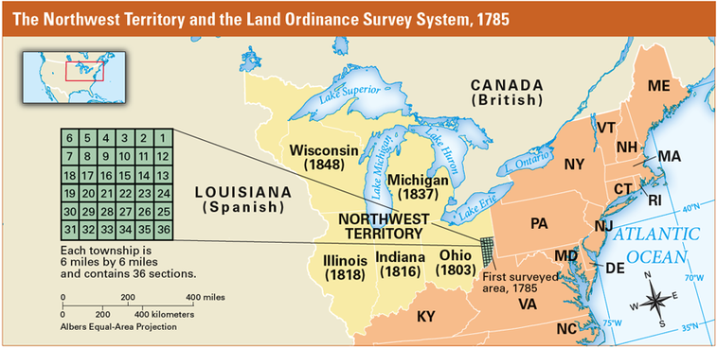
The Land Ordinance of 1785 organized the Northwest Territory into townships. The Northwest Ordinance of 1787 set rules for how western lands would be governed. Within a half-century of its passage, enough people had settled in the Northwest Territory to create five new states.
Surveyors proceeded to lay out townships in the Ohio Valley, then known as the Northwest Territory [Northwest Territory: a region of the United States bounded by the Ohio and Mississippi rivers and the Great Lakes. The region was given to the United States by the Treaty of Paris in 1783.] . By 1787, the government was ready to sell sections to settlers. This raised the question of how these areas should be governed. Were they to be U.S. colonies or new states?
The Northwest Ordinance Congress answered this question in the Northwest Ordinance [Northwest Ordinance: a law passed by Congress in 1787 that specified how western lands would be governed] of 1787. This law divided the Northwest Territory into smaller territories, each governed by a territorial governor. As soon as a territory had 5,000 free adult males, it could elect its own legislature, or lawmaking body. When the population reached 60,000, a territory could apply to Congress to become a state.
The Northwest Ordinance included a list of rights that gave settlers the same privileges as other citizens, except for one. Slavery was banned in the Northwest Territory.
This system of settlement served the nation well. Over time, the United States would continue to establish territories as it spread to the shores of the Pacific Ocean and beyond.
1. What issue did the Land Ordinance of 1785 address?
2. Into the space below, copy and complete this list of rules for the Northwest Territory.
Rules Set by the Northwest Ordinance
• When a territory has 5,000 free adult males, it can elect its own legislature.
•
• Settlers have the same rights and privileges as other citizens.
•

Section 3 - Shays’s Rebellion and the Need for Change

Click to read caption
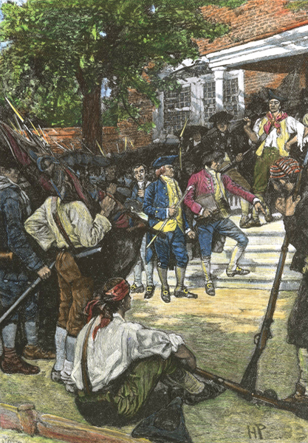
RF/Picture Research Consultants & Archives
Daniel Shays, at the top right, and his followers closed down courthouses in Massachusetts to prevent judges from seizing farmers’ land when the farmers could not pay their debts.
Under the Articles of Confederation, the new nation had serious money problems. The paper money printed by Congress during the war was worthless. Congress had the power to make coins that would not lose their value. But it lacked gold or silver to mint into coins.
The states reacted to the money shortage by printing their own paper currency. Before long, bills of different sizes and colors were distributed from state to state. No one knew what any of these currencies was worth, but most agreed they were not worth much.
Massachusetts Farmers Rebel The money shortage was particularly hard on farmers who could not earn enough to pay their debts and taxes. In Massachusetts, judges ordered farmers to sell their land and livestock to pay off their debts. Led by Daniel Shays, a hero of the Battle of Bunker Hill, Massachusetts farmers rebelled.
In 1786, Shays and his followers closed down courthouses to keep judges from taking their farms. Then they marched on the national arsenal at Springfield to seize the weapons stored there. Having disbanded the Continental army, Congress was unable to stop them.
The Massachusetts government ended Shays’s Rebellion in early 1787 by sending militia troops to Springfield to restore order. To many Americans, however, the uprising was a disturbing sign that the nation they had fought so hard to create was falling apart. “No respect is paid to the federal [national] authority,” James Madison wrote to a friend. “It is not possible that a government can last long under these circumstances.”
A Call for a Convention Shays’s Rebellion shocked Congress into calling for a convention to consider “the situation of the United States.” Each state was invited to send delegates to Philadelphia in May 1787 “for the sole and express purpose of revising the Articles of Confederation.”
Madison was ready. For the past year, he had devoted himself to the study of governments, both ancient and modern. The lesson of the past was always the same. A nation that was made up of many groups needed a strong central government, or it would soon be torn apart by quarrels. The question was, would Americans heed this lesson?

Student Text
Section 4 - Opening the Constitutional Convention
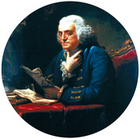
Click to read caption

Library of Congress
Benjamin Franklin, the oldest delegate to the Constitutional Convention, had doubts about the drafting of the Constitution. However, he said, “The older I grow, the more apt I am to doubt my own judgment and pay more respect to the judgment of others.”
Philadelphia was already hot and humid when delegates began drifting into the city. On May 25, 1787, the Constitutional Convention [Constitutional Convention: a meeting held in Philadelphia in 1787 at which delegates from the states wrote the U.S. Constitution] met for the first time in the east room of the Pennsylvania State House (now known as Independence Hall). The Declaration of Independence had been debated in this very room just 11 years earlier. The delegates would meet in the east room all summer. On some days, temperatures rose well into the nineties.
The delegates’ first action was to elect George Washington president of the convention. No man was more admired and respected than the former commander in chief of the Continental army. When the war ended, Washington could have used his power and popularity to make himself a king. Instead, he went home to Virginia to resume his life as an ordinary citizen. But despite his reluctance to return to public life, Washington would play a key role by presiding over the convention and lending it his prestige.
The Delegates Fifty-five delegates from 12 states attended the Constitutional Convention. Rhode Island, which prided itself as “the home of the otherwise minded” and feared a strong national government, boycotted the meeting.
Some leaders of the revolution were missing. John Adams and Thomas Jefferson were representing the United States in Great Britain and France, respectively. Others who did not attend included Sam Adams, John Hancock, and Patrick Henry. They feared that a strong national government would endanger the rights of states.
As a group, the delegates were, in the words of a modern historian, “the well-bred, the well-fed, the well-read, and the well-wed.” Their average age was 42. At 81, Benjamin Franklin of Pennsylvania was the oldest. He arrived at the convention each day in a sedan chair carried by four good-natured prisoners from a nearby jail.
Most of the delegates brought extensive political experience to the meeting. More than two-thirds were lawyers. Most had served in their state legislatures or held a state office. Thomas Jefferson was so impressed by the ability and experience of these men that he called the convention “an assembly of demi-gods.”
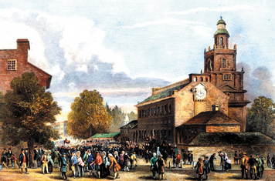
Click to read caption

The Granger Collection, New York.
The delegates to the Constitutional Convention met on May 25, 1787, in the same hall where the Declaration of Independence was signed. Today, the building is called Independence Hall.
The Father of the Constitution The best prepared of the delegates was James Madison of Virginia. One delegate wrote of Madison, “In the management of every great question he evidently took the lead in the Convention.” Indeed, Madison’s influence was so great that later he would be called the “Father of the Constitution.”
Madison addressed the convention numerous times. When he was not speaking, he took notes. Sitting near the front of the room so that he could hear everything that was said, Madison wrote down nearly every word. All together, his notes covered more than 600 printed pages. From this remarkable record, we know what went on inside the convention day by day.
The Rule of Secrecy At the time, however, no one outside the convention knew what was happening. After choosing a president, the delegates voted on rules for the convention. The most important of these was the rule of secrecy. The delegates wanted to feel free to speak their minds without causing alarm or opposition among the general public. They agreed to keep secret whatever was said in the meeting room until their work was done.
One day, Washington was handed some notes that had been dropped in the hall outside the east room. Washington pocketed the paper until the end of debate the next day. Then, in his sternest voice, he lectured the delegates on the importance of secrecy. “I know not whose paper it is,” Washington said as he flung the notes on his desk. “But there it is, let him who owns it take it.” The notes were never claimed. Instead, they lay on Washington’s desk for days.
Like Washington, the delegates took the rule of secrecy seriously. During that long summer, not a single word about the convention debates appeared in any newspaper.
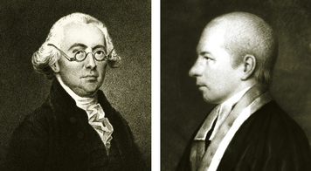
Click to read caption

Library of Congress
Delegates with opposing views were Pennsylvania’s James Wilson (left) and New Jersey’s William Paterson (right). Wilson, one of the most vocal delegates at the convention, argued for a strong national government. Paterson tried to protect the rights of the states. Many delegates of small states shared his fear of being “swallowed up” by the larger states.
Shared Beliefs and Clashing Views Once the convention was organized, the delegates got down to business. As a group, the delegates had much in common. But they also had very different views on many issues facing the new nation.
To be sure, all the delegates were committed [committed: to agree or pledge to support someone or something] to the ideals of the Declaration of Independence. The basic purpose of government, they believed, was to protect the rights to “life, liberty, and the pursuit of happiness.” And they agreed, in the words of the Declaration, that the “just powers” of governments came from “the consent of the governed.”
In part, these beliefs reflected the ideas of Enlightenment [Enlightenment: the “Age of Reason” in 17th- and 18th-century Europe. Enlightenment thinkers emphasized using rational thought to discover truths about nature and society.] thinkers like England’s John Locke. Human institutions, these liberal [liberal: supporting ideas of freedom, change, and progress] thinkers had argued, should be based on “laws of nature.” Among these laws were the rights to liberty and equality. The best way to protect these rights, the delegates agreed, was through some form of republic [republic: a country governed by elected representatives] .
From New England’s town meetings to lawmaking bodies like the Virginia House of Burgesses, Americans had a long tradition of participating in their own government. After the American Revolution, all the states had adopted constitutions [constitutions: a written plan that provides the basic framework of a government] that embraced republican ideals. Despite many differences in details, every state had some form of representative government. States had also expanded the rights to vote and to hold office. The state constitutions helped to shape the delegates’ thinking.
Despite the delegates’ broad agreement on a government “of the people,” many questions were left unanswered. For example, who exactly should have a say in a truly “representative” government? Even in liberal Pennsylvania, only free, white males could vote. Some states allowed only wealthier citizens to vote or hold office. Women could not vote in any state except New Jersey. (New Jersey women would lose the right to vote in 1807.)
Perhaps the most troubling question of all was how powerful the national government should be. Many delegates wanted to keep government close to the people by preserving the rights of the states. They feared that a strong national government would threaten individual liberty. Others, including Madison, argued just the opposite. Look at what has happened under the Articles of Confederation, they said, referring to events like Shays’s Rebellion. If the central government is too weak, it cannot do its job of protecting liberty and property.
As they met behind closed doors, the delegates wrestled with these and other issues. Tempers often flared. Several times it seemed the convention might collapse in failure. But in the end the delegates found ways to save the convention—and the nation.
1. Describe the role of each of these men at the Constitutional Convention.
• George Washington
• James Madison
2. Why did the important leaders Sam Adams, John Hancock, and Patrick Henry not attend the convention?
3. Do you agree with the delegates’ rule of secrecy? Why or why not?
4. The delegates had differing views on how powerful the national government should be.
a. What did delegates for a strong national government believe?
b. What did delegates for stronger state governments (weaker national government) believe?
c. List one belief that these two types of delegates shared.

Section 5 - Issue: How Should States Be Represented in the New Government?
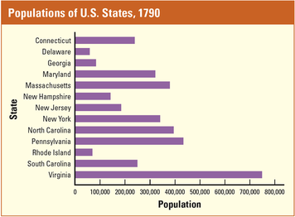
Click to read caption
Source: U.S. Census Bureau
A major issue confronting the Constitutional Convention was whether to give each state the same number of representatives or to base representation on population. Based on this graph, which states do you think would want equal representation for each state?
When the convention began, most delegates believed that their task was to revise the Articles of Confederation. To their surprise, the Virginia delegation presented them with a completely new plan of government. After a lengthy debate, the delegates made a bold move. They agreed to throw out the Articles of Confederation and write a new constitution.
While the delegates—later known as the framers—agreed to design a new framework [framework: a basic set of ideas used to develop a larger plan] of government, they were divided on a key issue. Where should the government’s power to rule come from? From the states? Or from the people? Under the Articles of Confederation, the answer was the states. James Madison’s answer was that the government’s power should come directly from the people.
The Virginia Plan Drafted by James Madison and proposed by Edmund Randolph, the Virginia Plan called for a strong national government with three branches, or parts. A legislative branch would make laws. An executive branch would carry out, or execute, the laws. A judicial branch, or system of courts, would apply and interpret the laws.
Under the Virginia Plan, Congress was to be made up of two houses, the House of Representatives and the Senate. The number of lawmakers that a state could send to Congress depended on the state’s population. States with large populations would have more representatives than smaller states would have.
Delegates from Virginia, Pennsylvania, and other large states liked the Virginia Plan. Having the new government represent people, not states, would give them more representatives and more power in both houses of Congress.
The New Jersey Plan Not surprisingly, delegates from the small states disliked the Virginia Plan. Just as the convention was about to vote on it, William Paterson of New Jersey introduced a rival proposal.
Like the Virginia Plan, the New Jersey Plan called for a government with three branches. However, the legislative branch would have just one house, not two. Each state would have an equal vote in Congress, no matter how big or small. This plan, Paterson argued, would keep the small states from being “swallowed up” by their more populous neighbors.
1. Tell how each of these would answer this question: Where should the government’s power to rule come from?
• Articles of Confederation
• James Madison
2. Complete the matrix to explain the differences between these two plans of government.

Section 6 - Resolution: The Great Compromise
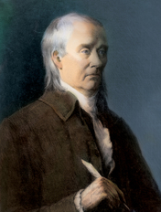
Click to read caption

Library of Congress
Roger Sherman, a signer of the Declaration of Independence, helped construct the Great Compromise that called for a Congress with two houses.
The New Jersey Plan was warmly received by delegates from small states. The majority of delegates, however, saw William Paterson’s plan as offering little improvement over the Articles of Confederation and rejected it. But they could not agree on what should replace it.
Tempers Rise The debate over representation in Congress continued into July, with tempers rising day by day. To most delegates from large states, representation based on population seemed both logical and fair. “Can we forget for whom we are forming a Government?” asked James Wilson of Pennsylvania. “Is it for men, or for the imaginary beings called States?”
To Wilson, the answer was obvious. But his logic could not overcome the fears of small-state delegates. One hot Saturday afternoon, Gunning Bedford of Delaware tore into the delegates from large states. “They insist,” he said, “they will never hurt or injure the lesser states.”His reply to his own concern was straightforward. “I do not, gentlemen, trust you!” If the large states continued in their efforts to “crush the smaller states,” Bedford warned, “the small ones will find some foreign ally of more honor and good faith who will take them by the hand and do them justice.”
Rufus King of Massachusetts was shocked at this reference to foreign powers. He said that he was “grieved, that such a thought had entered his heart.” Still, every delegate knew that Great Britain, France, and Spain were just waiting for the United States to fall apart so they could pick up the pieces.
A Compromise Is Reached Finally, a compromise was proposed based on a plan put forward earlier by Roger Sherman of Connecticut. The compromise plan kept a two-house Congress. The first house, the House of Representatives, would represent the people. In this house, the number of representatives from each state would be based on the state’s population. The second house, the Senate, would represent the states. Each state would have two senators, to be elected by their state legislatures. The vote was very close, but the compromise plan was approved. This plan saved the convention and became known as the Great Compromise [Great Compromise: the plan of government adopted at the Constitutional Convention that established a two-house Congress. In the House of Representatives, representation from each state is based on state population. In the Senate, each state is represented by two senators.] .
1. Who created the plan that became know as the Great Compromise?
2. According to the Great Compromise, how are states represented in the House of Representatives of the Congress? Does this favor the people or the states?
3. According to the Great Compromise, how are states represented in the Senate? Does this favor the people or the states?

Section 7 - Issue: How Should Slaves Be Counted?
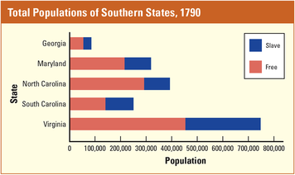
Click to read caption

Source: U.S. Census Bureau
How do you think delegates from each of the states shown in this graph would want slaves to be counted? Would they want the slave population to be considered when determining representation in Congress, or would they want slaves to be counted as property that could be taxed?
The Great Compromise kept the framers working together. But having agreed to base representation in one house of Congress on state population, they faced a new and difficult question. As Gouverneur Morris of Pennsylvania put it, “Upon what principle shall slaves be computed in the representation?”
People or Property? By the time of the convention, nine-tenths of the slaves in the United States lived in the South. Like everyone else, southerners wanted as many representatives in the House as possible. They argued that slaves should be counted the same as any other people in determining representation.
Delegates from the North challenged this idea. Were slaves to be considered people with a right to be represented in Congress? Or were they property? “Blacks are property and are used to the southward as horses and cattle to the northward,” argued Elbridge Gerry of Massachusetts. Most northern delegates agreed. Slaves should be counted only as property that could be taxed like any other property. If slaves were to be counted as people in determining representation in Congress, said Morris, “then make them citizens and let them vote.”
New Thinking on Slavery This argument signaled a growing division among white Americans. The Declaration of Independence and the American Revolution forced many whites to reexamine their views on slavery. Some became active in trying to end what they now saw as a great evil. Benjamin Franklin, for example, became president of an antislavery society in 1787. In the North, this new thinking led one state after another to pass laws ending slavery.
Although many southerners were uneasy about slavery, they were not yet ready to abolish it. The South’s economy was still very dependent on the labor of enslaved African Americans. But some southern states did pass laws making it easier for owners to free their slaves.

1. What might each of these delegates have said about how slaves should be counted for representation in Congress?
• Delegate from the North
• Delegate from the South
2. Compare the growing division in attitudes toward slavery by writing what each of these delegates might have said.
• Delegate from the North
• Delegate from the South

Section 8 - Resolution: The Three-Fifths Compromise
After a bitter debate, Madison proposed a compromise. Count each slave as three-fifths of a person, he suggested, when determining a state’s population for representation in the House of Representatives. The delegates approved this idea, which became known as the Three- Fifths Compromise [Three- Fifths Compromise: an agreement made at the Constitutional Convention stating that enslaved persons would be counted as three-fifths of a person when determining a state’s population for representation in the House of Representatives] , because it seemed the only way to keep the convention moving forward.
Another Slavery Issue A dispute over trade raised another issue about slavery. To help business in the North, northern delegates favored giving Congress broad power to control trade between the states and other countries. This proposal made southern delegates nervous. They worried that Congress might try to tax southern export crops such as rice and tobacco. Southerners also worried that Congress would use its power over trade to outlaw the slave trade—the importing of slaves from Africa.
Southerners had reason to be fearful. By 1787, several states had outlawed the slave trade within their boundaries. A majority of the convention’s delegates favored ending the slave trade completely
South Carolina and Georgia, however, objected that their economies would collapse without a constant supply of new slaves. Neither state would agree to any constitution that threatened to end the slave trade
More Compromises on Slavery Again, the delegates settled on a compromise. Congress would have the power to control trade, but with two limitations. First, Congress could not place any tax on exports to other countries. Second, Congress could not interfere with the slave trade for 20 years, or until 1808.
To satisfy southerners, the delegates also agreed to a provision known as the fugitive slave clause. This clause said that escaped slaves had to be returned to their owners, even if they were caught in a free state.
Without such compromises, the states might never have come together in a single union. Still, the compromises only postponed the day when Americans would have to resolve the terrible contradiction [contradiction: a difference between two statements or situations that means they cannot both be true] between slavery and the ideals of liberty and equality. Meanwhile, generations of African Americans would spend their lives in bondage.
1. How did the Three-Fifths Compromise work? Create and label a simple drawing to illustrate your answer.
2. What compromise did the delegates reach on the slave trade?

Section 9 - Issue: How Should the Chief Executive Be Elected?
Another major question facing the delegates concerned who would head the new government’s executive branch. Early in the convention, Charles Pinckney urged the creation of a “vigorous executive.” James Wilson followed with a proposal that a single person serve as the chief executive.
A sudden silence fell over the convention. A single executive? The very idea brought to mind unhappy memories of King George III.
Wilson broke the silence by explaining that good government depends on clear, timely, and responsible leadership. Such leadership, he said, is most likely to be found in a single person.
One Executive or Three? Edmund Randolph of Virginia disliked this proposal. He preferred a three-member executive drawn from different parts of the country. Three people, he argued, could lead the country better than one.
Benjamin Franklin opposed a single executive for different reasons. “The first man put at the helm will be a good one,” said Franklin, thinking of George Washington. “Nobody knows what sort may come afterwards.” The next chief executive, he warned, might be overly ambitious or too “fond of war.”
In spite of these objections, the framers agreed to a single executive, to be called the president. To keep this leader from becoming too kinglike, they limited the president’s term to four years. A vice president was also to be elected to fill that term if the president died in office.
Choosing the Chief Executive Equally troubling was the issue of how to choose the chief executive. Some delegates wanted Congress to appoint the president. Gouverneur Morris objected. The president “must not be made the flunky of the Congress,” he argued. “It must not be able to say to him: ‘You owe your appointment to us.’”
Several delegates thought that the people should elect the president. Madison, however, argued that voters would naturally vote for someone from their own state. As a result, this method would not be fair to candidates from small states.
Still others suggested that the president be elected by a specially chosen group of “electors” from each state. Such a group, they felt, would be able to look beyond state interests to make a wise choice for the entire country.

1. Write at least one argument for each of these proposals:
• Delegate Who Believes the Nation Should Have a Single Executive
• Delegate Who Believes the Nation Should Have a Three-Member Executive

2. List the three proposals given for choosing the chief executive. Which one do you think is the best?

Section 10 - Resolution: The Electoral College
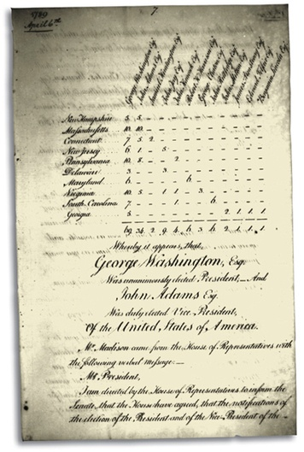
Click to read caption

U.S. Senate Legislative Collections
This is a copy of the Electoral College vote for the election of 1789. At that time, which states had the most electoral votes?
After some 60 votes on the issue of how to elect the president, the framers reached another compromise. Neither Congress nor the people, they decided, should choose the president and vice president. Instead, a special body called the Electoral College [Electoral College: the group established by the Constitution to elect the president and vice president. Voters in each state choose their electors.] would elect the government’s leaders.
The Electoral College System The Electoral College is made up of electors who cast votes to elect the president and vice president every four years. Each state has as many electors in the Electoral College as the number of senators and representatives it sends to Congress. The votes cast by electors are called electoral votes.
The delegates left the method of choosing electors up to each state. Before 1820, state legislatures chose electors in most states. Today, the people choose their state’s electors when they vote in presidential elections. The electors then cast their ballots for president and vice president on a date chosen by Congress.
Originally, the electors voted for two candidates without saying which one they preferred for president or vice president. The candidate receiving the most votes became president. The runner-up became vice president. This system caused great confusion in the election of 1800 and was later changed.
Political Parties and Elections The Electoral College system seems very odd to most Americans today. In our age of instant communication, it is hard to appreciate the framers’ concern that voters would not know enough about candidates outside their own state to choose a president wisely.
The delegates could not have predicted how quickly communications would improve in the United States. Nor could they foresee the rise of national political parties. Within a few years of the convention, political parties were nominating candidates for president and educating voters in every state about those candidates.
The Electoral College system still affects presidential elections today. In most states, the candidate who gets the most votes—even if less than a majority— wins all of that state’s electoral votes. As a result, a candidate can win a majority in the Electoral College without necessarily winning a majority of the votes cast across the country. In the presidential election of 2000, George W. Bush won the presidency over Al Gore by getting the most Electoral College votes, even though Gore received more votes than Bush in the popular election.
1. How many electors does each state have in the Electoral College?
2. Describe one way that presidential elections have changed over time.

Section 11 - The Convention Ends
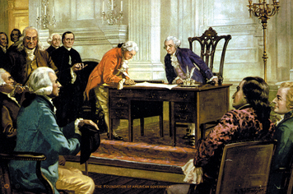
Click to read caption

Library of Congress
Only 39 of the original 55 delegates signed the Constitution on September 17, 1787. Thirteen delegates had returned home before the conclusion of the convention, and three others refused to sign.
By the end of summer, the hard work of designing the Constitution was finished. But the new plan still had to be approved by the states.
Approving the Constitution The first question before the framers was how many states would have to ratify [ratify: to formally approve a plan or an agreement. The process of approval is called ratification.] , or approve, the Constitution before it could go into effect. Should ratification require approval by all 13 states? By a majority of 7 states? The framers compromised on 9 states.
The second question was who should ratify the Constitution—the people or the state legislatures? Ratification by state legislatures would be faster and easier. James Madison, however, argued strongly that the people were “the fountain of all power” and should decide. The majority of delegates agreed. After the delegates signed the Constitution, the document was later ratified at special conventions by delegates elected by the people in each state. However, ratification did not come without difficulty.
Signing the Constitution On September 17, 1787, the delegates declared the Constitution complete. As this last meeting began, Franklin shared his final thoughts, which would be printed in more than 50 newspapers.
“I confess that I do not entirely approve of this Constitution, “Franklin began. Then he pointed out that no convention could produce a perfect plan. “It therefore astonishes me,” Franklin continued, “to find this system approaching so near to perfection . . . and I think it will astonish our enemies.” Franklin added that he approved the final plan “because I expect no better, and because I am not sure that it is not the best.” He urged every member of the convention to “put his name to this instrument.”
Not everyone was won over by Franklin’s words. Thirteen delegates left the convention before it ended and so did not sign the Constitution.
Three other delegates—Edmund Randolph and George Mason, both of Virginia, and Elbridge Gerry of Massachusetts—also did not sign. Mason believed it gave too much power to the national government. Gerry refused to sign because he believed the new plan did not protect the rights of the people.
When the signing was over, Franklin confessed that he had often looked at the sun carved on the back of George Washington’s chair and wondered whether it was about to rise or set. “But now,” he said, “I have the happiness to know that it is a rising and not a setting sun.”A new day was dawning for the United States.
1. Fill in the speech bubbles to show how each of these delegates might have answered a reporter who asked, “Did you sign the Constitution? Why or why not?”

Section 12 - The Constitution Goes to the States
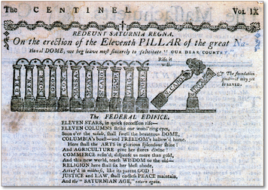
Click to read caption

Library of Congress
The Constitution had to be approved by nine states. This political cartoon shows 11 states, pictured as columns, supporting the Constitution, while two states are hesitating.
Newspapers in every state printed the Constitution as soon as they could get it. What readers found was a plan that would create a “federal” system of government, in which a strong national government shared power with the states. Before long, the entire country was debating the same issues that had kept the convention in session for four long months.
The Federalists Supporters of the Constitution called themselves Federalists. The Federalists argued that the Constitution would create a national government that was strong enough to unite the quarreling states into a single republic.
James Madison, Alexander Hamilton, and John Jay led the Federalist campaign for ratification. In a series of newspaper essays, they recalled the weaknesses of the government under the Articles of Confederation. They showed how the Constitution would remedy those weaknesses by creating a stronger, more effective union of the states.
The Federalist leaders also addressed the fears of many Americans that a strong government would threaten their freedom or take away their rights. The powers given to the government, they pointed out, were strictly limited. In addition, those powers were divided among three branches so that no one branch could become too powerful. The influential articles written by Madison, Hamilton, and Jay were later collected and published as The Federalist Papers [The Federalist Papers: a series of essays written by James Madison, Alexander Hamilton, and John Jay in support of the ratification of the Constitution by the states] .
The Anti-Federalists Opponents of the Constitution were known as Anti-Federalists. They found much to dislike about the new plan. Congress, they feared, would burden the country with taxes. They claimed the president had power enough to rule like a king. The judicial branch, they said, would overpower state courts.
The Anti-Federalists also complained about what was missing from the plan. Their main complaint was that the plan listed the powers of the government but not the rights of the people. Most of all, the Anti-Federalists feared change. The idea of giving up any state power to form a stronger Union made them uneasy.
After listening to the arguments, Madison wrote that the question facing the nation was “whether the Union shall or shall not be continued. There is, in my opinion, no middle ground to be taken.”

1. Write a one-paragraph letter to the editor of a newspaper from the perspective of a Federalist supporting ratification of the Constitution.
I support ratification because . .

2. Write a one-paragraph letter to the editor opposing ratification as an Anti-Federalist.
I do not support ratification because .

Summary
In this chapter, you read about the Constitutional Convention, the historic meeting that replaced the Articles of Confederation with a new plan of government.
Early Quarrels and Accomplishments Under the Articles of Confederation, Congress did not have the power to solve disagreements among states over such issues as taxes. Congress passed laws on how to settle the Northwest Territory.
Shays’s Rebellion Shays’s Rebellion showed that under the Articles of Confederation, the government was too weak to keep order.
The Great Compromise In 1787, delegates met at the Constitutional Convention and agreed to revise the Articles. The Great Compromise established how states were to be represented in the legislative branch of government.
The Three-Fifths Compromise The Three-Fifths Compromise settled the question of how slaves were to be counted in determining a state’s population.
The Electoral College A third compromise created a single chief executive, to be chosen by the Electoral College.
The Constitution Delegates signed the Constitution in September 1787. They agreed that 9 of the 13 states had to ratify the Constitution before it could go into effect.
1. Create a flyer that might have been used to encourage people to support ratification of the Constitution. Your flyer must have
• a catchy slogan.
• three reasons why states should ratify the Constitution.
• writing that uses correct spelling and grammar.

