Reading Further - James Madison and the Long, Hot Summer of 1787
James Madison is often called the “Father of the Constitution.” Although many people had a hand in shaping the Constitution, most scholars agree that Madison was the main driving force behind the document’s creation. It was a process that took more than 100 days of complex negotiation and compromise. Even so, it did not turn out quite as Madison had wanted.
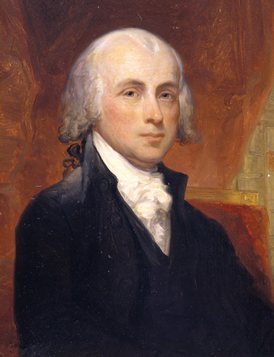
Click to read caption

Réunion des Musées Nationaux / Art Resource; NY
The scholarly James Madison finished college in two years, and then studied law. By the time he arrived at the Constitutional Convention, he was experienced in state and national politics.
In the first week of May 1787, James Madison stood alone in the East Room of the Pennsylvania State House. Within a few weeks, many of the nation’s political leaders would gather there. Although few of them knew it at the time, their task would be to create a new plan of government for the United States. Madison knew it, though, and he wanted to be ready.
Madison had thought long and hard about the great challenges facing the nation. Under the Articles of Confederation, the United States was floundering. Madison believed that a stronger national government was needed to keep the country on course. Other leaders also agreed on the need for reform. However, many of them had fears of a strong central government. Madison would have to work hard to change those ideas.
Madison had arrived early in Philadelphia to prepare for the convention. He had checked in to one of the city’s finest boarding houses, run by Mrs. Mary House. Soon most of his fellow delegates from Virginia would be there also. That would give them a chance to make plans before the convention began.
Unfortunately, it was not a fine time to be in Philadelphia. It had been a wet and rainy spring. Now, as summer neared, it was becoming increasingly hot and humid. To make matters worse, the city was plagued with dense clouds of black flies. Residents had to sleep with their windows closed or be tormented by swarms of buzzing, biting insects. Shutting their windows, however, meant they had to spend their nights sweltering in the heat.
Madison had bigger concerns, though. As he looked around the East Room of the State House, he imagined the events that would soon unfold there. The room was large, with a 20-foot-high ceiling and tall windows. But it would be crowded once all the delegates were seated. Madison decided to sit up front, where he could get a clear view of the proceedings. He planned to take notes and wanted to be able to see and hear everything that took place at the convention.

Madison Leads the Way
Madison was 36 years old at the time of the convention. He was a small man, just five and a half feet tall, with pale skin and thinning hair. He typically dressed in black. He was shy and spoke in a soft voice that was often hard to hear. Nevertheless, he had great energy. He walked with a bounce in his step and could get by on just a few hours of sleep a night. Although he rarely showed personal warmth or charm, he was a brilliant conversationalist who knew how to win others to his side.
Madison was well prepared to play a leading role at the convention. He had spent several years as a member of Congress. He had studied the writings of great political thinkers and understood how political systems worked. He had also helped write the Virginia Constitution of 1776. This document established a state government with separation of powers and a two-house legislature. It was an important model of democratic government. Madison would bring all this past experience to bear at the convention.
Over the next two weeks, the other delegates began to arrive. They were all wealthy, educated white men. Most were lawyers or large landowners. There were no workers or tradesmen. There were also no women, African Americans, or American Indians.
The delegates took rooms at various boarding houses and inns. One of these inns, the Indian Queen, was the largest in the city. Soon it would be filled with leaders from around the nation. Here they would gather to eat, drink, and swap stories. It was a center of social activity during the convention.
By mid-May, most of the Virginia delegation had arrived. This group included three major political figures: George Washington, George Mason, and Edmund Randolph. These men met with Madison late into the night. Together they came up with a plan for a new government, a set of 15 proposals now known as the Virginia Plan. This plan embodied Madison’s ideas on the kind of government the nation needed.
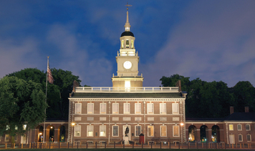
Click to read caption

RF/scoutingstock/Shutterstock
Now called Independence Hall, this Philadelphia building is the birthplace of our nation’s independence. The Declaration of Independence was signed here in 1776. The Articles of Confederation were adopted here in 1781. And the U.S. Constitution was created here in 1787.

The Convention Begins
On May 14, the convention was due to begin, but many delegates had still not arrived. Travel was difficult in those days. The roads were bad and coaches often got stuck in the mud or broke an axle. A trip that normally took a week might take much longer because of problems on the road.
Finally, on May 25, the convention got underway. For the next four months, the delegates would gather in the East Room to debate the issues. To maintain secrecy, they agreed to bolt the doors and shut the windows. As the summer wore on, the heat increased. Many of the men wore wigs and wool suits, and with the doors and windows closed the room was stifling. In this hothouse atmosphere, arguments were often intense.
Through it all, Madison sat at his table near the front, scribbling away at his notes. In the evening, he took these notes back to his room and laboriously copied them out, word for word. It was an ordeal that “almost killed” him, he said. But he was determined to keep a complete and accurate record of the convention.

Debating the Virginia Plan
From the start, the convention focused much of its attention on the Virginia Plan. On May 29, Edmund Randolph presented the various points of the plan. The next day, he summed up its main idea in a bold proposal: “that a national Government ought to be established consisting of a supreme Legislative, Executive & Judiciary.” Amazingly, Randolph’s proposal was approved with little debate. Madison had achieved his first major goal without a struggle. The convention had agreed to form a new government. But winning support for the plan’s details would prove much more difficult.
The toughest issues involved the national legislature. The delegates all agreed that Congress was a key part of government. But they disagreed on how the people and the states should be represented in Congress. Convention leaders like Madison knew that this dispute could derail the convention. So, they focused on what they thought would be a simpler issue—the executive branch. But this turned out to be a tough issue, too. Should there be one executive or three? How long should the executive serve? Should the executive be elected or appointed? For a week, the debate circled around and around these questions. Delegates would vote on a question, discuss it some more, and vote again.
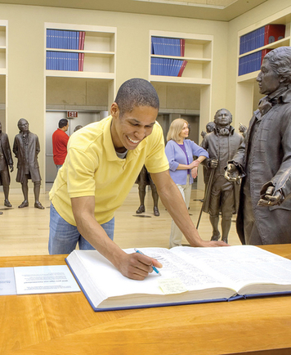
Click to read caption

National Constitution Center
Visitors to the National Constitution Center in Philadelphia can make a choice the framers once made: to sign or not to sign a copy of the Constitution. In Signers’ Hall, bronze statues of the framers stand together. Visitors are encouraged to consider the choices that each man made in 1787.

Crafting a Final Document
Frustrated by this seemingly endless debate, on June 9 the delegates decided to tackle the thorny problem of representation in the legislature. The month-long debate was so fierce that, at times, it looked like the convention would fall apart. But the delegates always pulled back from the brink. Finally, on July 16, they approved the Great Compromise, which set different forms of representation for the two houses of Congress. Depressed, Madison realized that he had lost his battle for a legislature based solely on representing the people rather than the states. But with the greatest battle behind them, the framers could work toward a final plan for the new government.
By late August, the delegates formed the Committee on Postponed Matters to take up the few issues that remained to be resolved. A few days later, the committee reported back with its findings. More debate followed. But by early September, a Committee on Style—consisting of Madison and four others—was formed to prepare a final draft to present to the full convention.
Ever mindful of the importance of this plan for the nation, the delegates made a few more changes. Finally, Gouverneur Morris of New Jersey handwrote the final document—4,300 words in all. “On the question to agree to the Constitution, as amended,” Madison recorded in his notes, “All the states, ay [yes].” And so at last, on September 17, 1787, most of the delegates signed the Constitution. It was ready to go to the states for ratification.
The exhausted delegates had finally completed their monumental task. The Constitution was not everything James Madison had hoped for. In his view, it left too much power in the hands of the states. But he had done what he could and was prepared to live with the outcome. Now he would turn to the fight for ratification and the task of creating a new government.
1. Preparing to Write: Taking Notes
Whether for newspaper, television, radio, or the latest blog, reporters always want to capture “the big story.” Newspapers were important in 1787, too. News of the Constitution was announced in papers in all 13 states.
Suppose you were a newspaper reporter on September 17, 1787. The Constitution has just been signed. Your assignment is to write an article about the new Constitution and the convention that created it. In the article, you will describe the event and important issues that were discussed.
Reporters begin by making notes. Use what you have learned about the convention to complete this reporter’s notebook.
Notes on the Constitutional Convention
What (was the event)
Where (did it happen)
When (did it happen)
Who (was there)
Why (was it happening)
2. Write down a question you would like to ask three of the delegates. Record what you think they would have replied.
3. Writing a Newspaper Article
Now, write your newspaper article. Your article should clearly report events and issues of the convention and have no spelling or grammar errors. The interviews should give accurate information and opinions. Be sure to give your article a headline, a byline (your name as the reporter), and a dateline (the location and date of the article—in this case, Philadelphia, September 17, 1787).

