STUDY GUIDE FOR DDM-
CAUSES OF THE AMERICAN REVOLUTION
(Hello students! Please complete this study guide in preparation for next week’s DDM assessment on Wednesday. We will complete our debate on Monday and complete a study review game on Tuesday.)
- Which country gained territory in North America as a result of the French and Indian War?
_______________________________________________________________________
- Which group of people benefited from the Proclamation of 1763?

_______________________________________________________________________
- Before 1760, which group passed laws in the colonies?

_______________________________________________________________________
- Tell three results of the French and Indian War.
________________________________________________________________________________________________________________________________________________
- Which group formed the Sons of Liberty?

________________________________________________________________________
- What was the effect of the Townshend Acts?

________________________________________________________________________
- Why was the event on March 5, 1770, given the name, Boston Massacre?
________________________________________________________________________________________________________________________________________________
________________________________________________________________________

- What did the colonists resent most about the Stamp Act?
________________________________________________________________________________________________________________________________________________________________________________________________________________________

- What was Great Britain’s response to the Boston Tea Party?
________________________________________________________________________________________________________________________________________________________________________________________________________________________

- In which ways did Great Britain increase its control of the colonies?
________________________________________________________________________________________________________________________________________________________________________________________________________________________

- What was the goal of the First Continental Congress?
________________________________________________________________________________________________________________________________________________________________________________________________________________________

- How did colonists view themselves in 1774?
________________________________________________________________________________________________________________________________________________________________________________________________________________________

- How did Parliament respond to the colonists’ protests against the Stamp Act?
________________________________________________________________________
_________________________________________________________________________
_________________________________________________________________________

- How did many of the Loyalists view the Patriots? ________________________________________________________________________________________________________________________________________________________________________________________________________________________

- What did the colonists consider acts of tyranny?
________________________________________________________________________________________________________________________________________________________________________________________________________________________________________________________________________________________________________________________________________________________________________

- What became evident when the colonists and British troops clashed at
Lexington and Concord?
__________________________________________________________________________
__________________________________________________________________________
__________________________________________________________________________

- What led to the colonists to dump tea into Boston Harbor
on December 16, 1773? ________________________________________________________________________________________________________________________________________________________________________

- Who was also active in the midnight ride? ________________________________________________________________________
- Patrick Henry gave a famous speech that ended with the words “give me liberty,
or give me death!” With which group did he identify himself?
________________________________________________________________________________

- Which of the following acts required colonists to house British soldiers?
________________________________________________________________________
- What is the Declaratory Act? ( scavenger hunt) –I know we did not discuss this act
________________________________________________________________________
- What was a purpose of Paul Revere’s ride?
_______________________________________________________________________________________________________________________________________________________________________________________________________________________
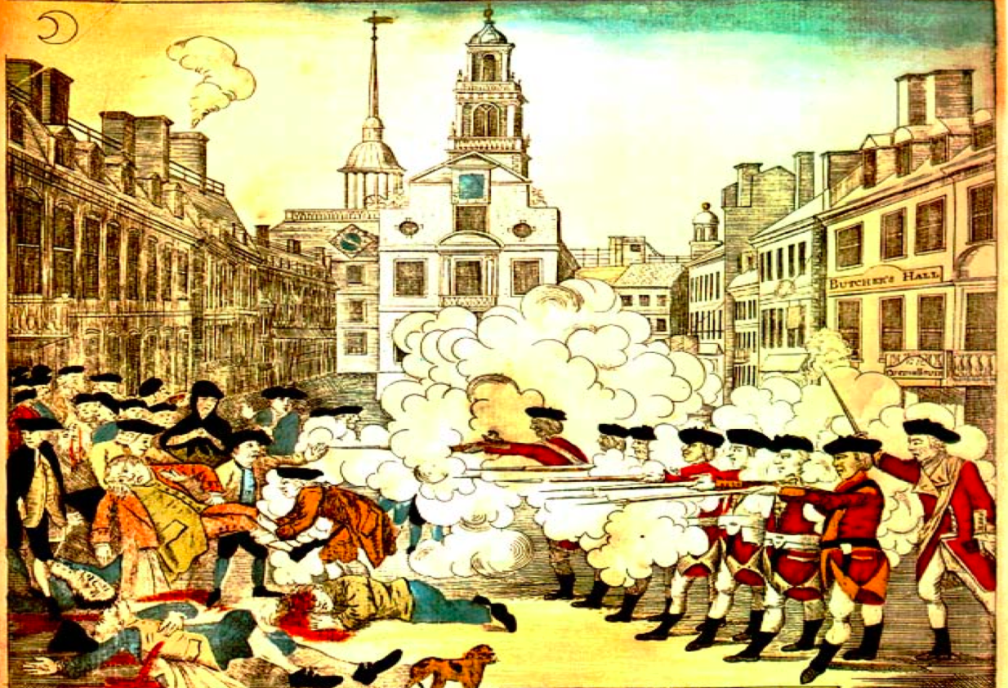

1. What event is shown in the illustration and who was the artist?
2. How is this image different from the actual historic event? Cite evidence using the John Adams video as well as the primary sources you received in class. Make sure to also use vocabulary words relevant to the task such as biased and propaganda.

